Purpose

This guide is to assist external customers in submitting, and self-issuing a garage sale permit.

General Information

* Must be a registered portal user. Registration Process
* For garage sale permit details refer to LDC 04-41 as amended, 5.06.06 Signs.
* The permit must be posted on the property where the garage sale is held

Procedure

* 1. Applying for A Garage Sale Permit

*Make sure you are a registered user with our GMD Public Portal*

1. **Sign In** 
   1. Click Sign In
      * Enter email address
      * Enter password
   2. Click Login

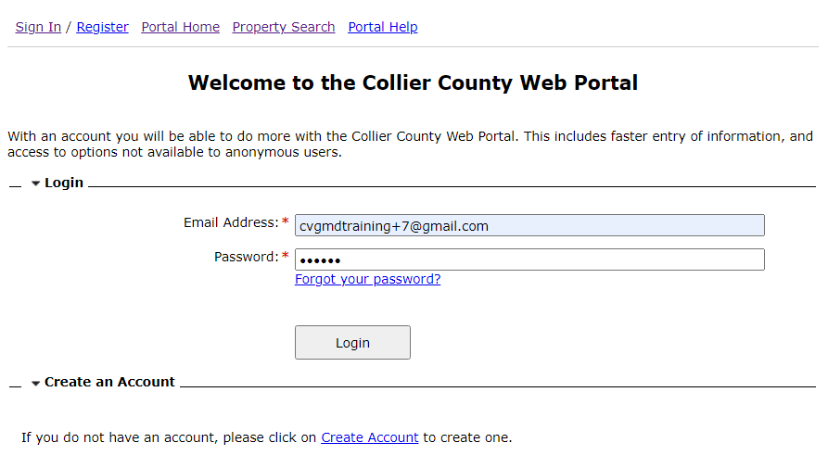

1. **Under Special Events, Zoning Certificates, Temporary Use, and RV & Garage Sale Permits** 
   1. Click Apply for Permit

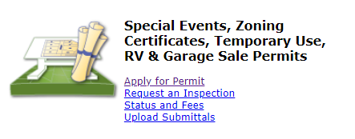

1. **Permit or Certificate – Project Description** 
   1. Choose the project type
      * *Garage Sale Permit*
   2. Project Descriptive Name and Project Description autoloads, enter additional comments about the project if necessary
   3. Name on Permit
      * This name will show on the permit
   4. Enter Contact Phone number
   5. Click Next Step: Permit Type

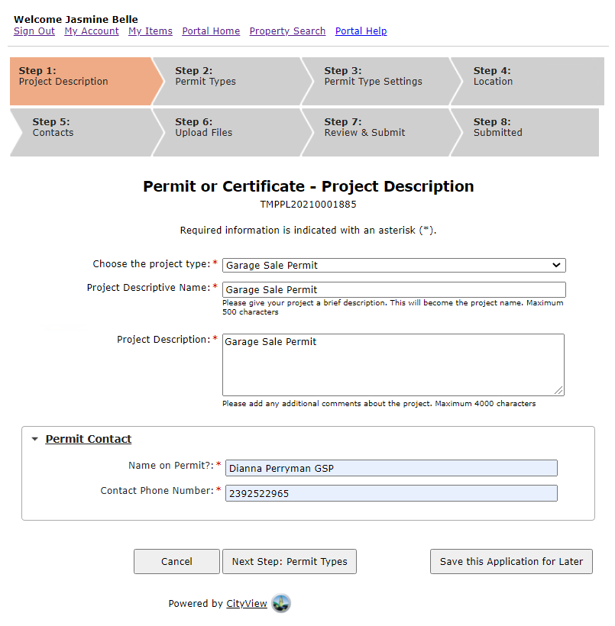

1. **Permit or Certificate – Permit Type Settings**
   1. Enter Start Date
      * Click Calendar and select a date
   2. Select Number of days
      * Choose 1 or 2 days from the drop-down list
   3. Where is the Garage Sale
      * Select Residential from the drop-down list

Note: If you select *Commercial* your application will be cancelled and you will receive an error message providing instructions. If this is a garage sale in a district other than residential, you must a apply for a Special event Permit.

* 1. I have not held a garage sale in the last six months
     + Select **True**

Note: If you select *False* your application will be cancelled and you will receive this error message providing instructions

* 1. Click Next Step: Location

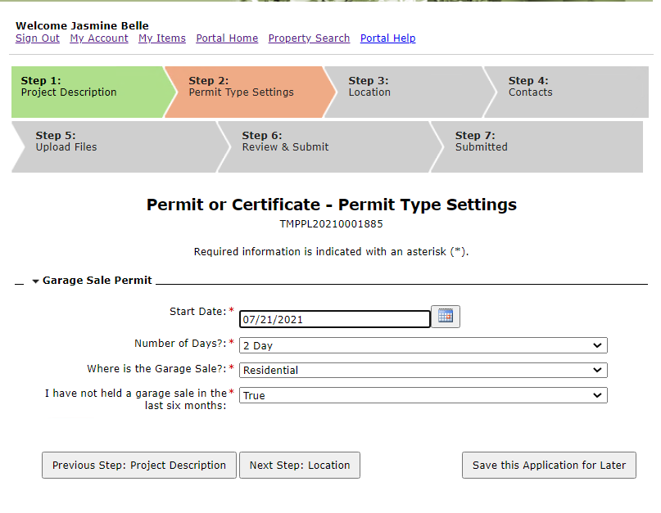

1. **Permit or Certificate – Location of Project** 
   1. Search for address
      * Select address from the list
      * Make sure address loads in The location you have selected box
   2. Click Next Step: Contacts

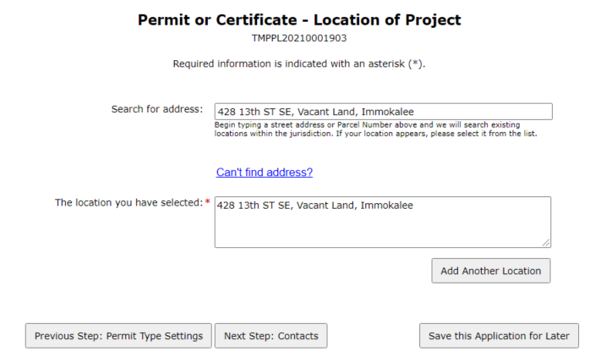

***Note:*** if the address does not populate in the list you must click Can’t find address and enter the address manually.

1. **Permit or Certificate – Review & Submit**
   1. Review the information entered, If changes are required, use the Previous button to go back and make the correction

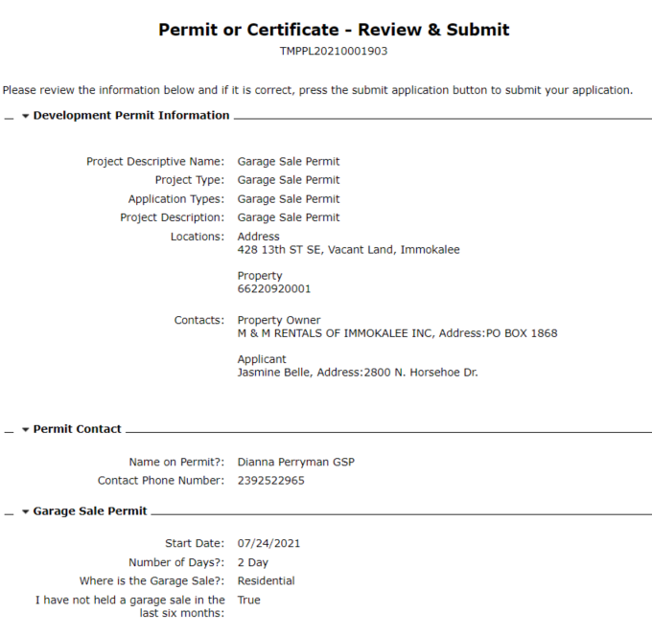

* 1. Scroll down to ***Acknowledgement***
     + Select Agree
     + If you select *Disagree* you can not move forward to submit your application
  2. Type in the capture characters you see in the image in the box below it
  3. Click Submit Application

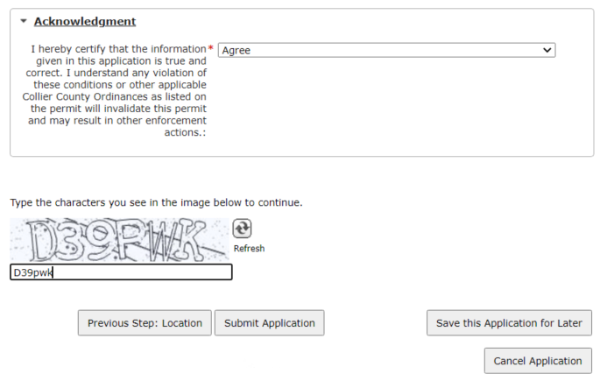

1. **Permit or Certificate – Submitted** 
   1. Application Number is assigned
   2. Review the information, If changes are required, use the Previous button to go back and make the correction
      * Scroll down to the bottom of the page, Under Document Name
        1. Click on Garage Sale
        2. Download and Print

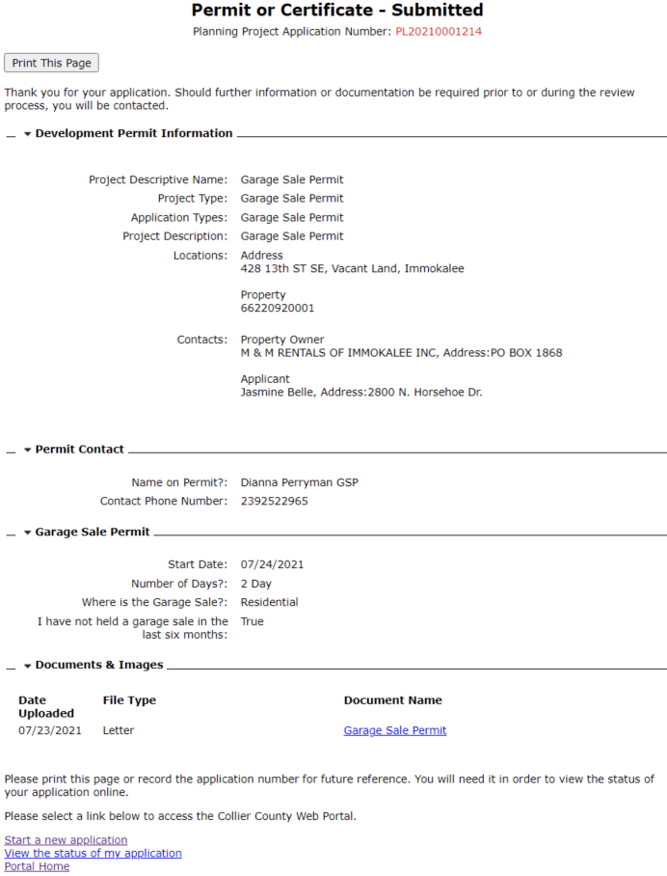

1. **Post Garage sale permit on property**

