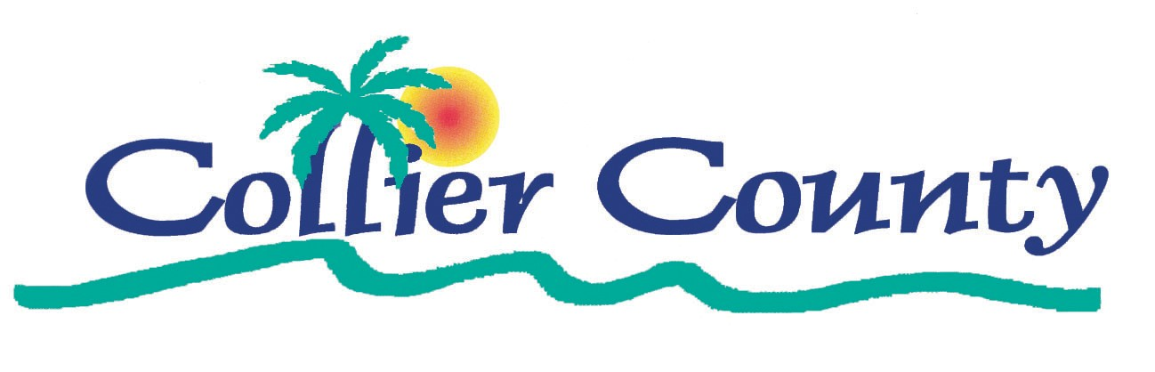

-IMMOKALEE, FLORIDA-
ECONOMIC INCENTIVES AVAILABLE

SUMMARY
AND
CONTACT INFORMATION

BENEFITS ARE IN $$$$

Prepared by: Immokalee Enterprise Zone Development Agency

Immokalee Community Redevelopment Authority Advisory Board

October, 2006

Collier County, Florida

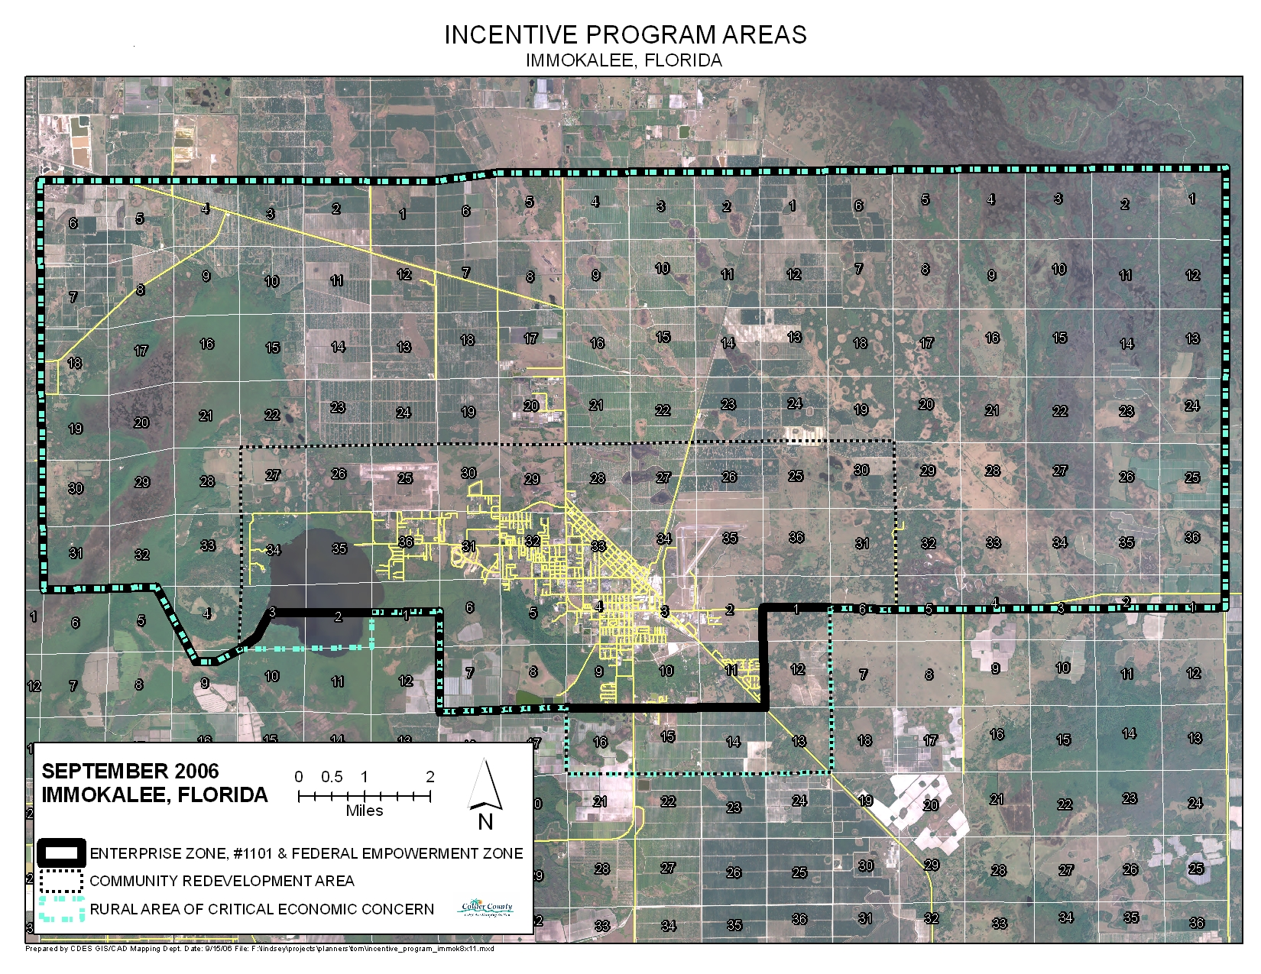

-IMMOKALEE, FLORIDA-
ECONOMIC INCENTIVES AVAILABLE
SUMMARY AND CONTACT INFORMATION
BENEFITS ARE IN $$$$
Economic Incentive Programs Available. The Immokalee Area of Florida (see opposite page) is a rural area in economic transition. This Area provides business-friendly incentives which include financial, training, and expedited permitting. The following are summarize some of the key business-friendly incentives and programs and how to learn more about each.

- State of Florida Immokalee Rural Enterprise Zone #1101
Incentives, in brief: Jobs tax credits…corporate, sales and use tax; Sales tax refunds for business machinery, equipment, building materials, and electrical energy used; Property tax credit equal to 96% of ad valorem taxes; and Community contribution tax credit with review and recommendations of the Immokalee Enterprise Zone Development Agency.
Contacts: Collier County Comprehensive Planning Department: Joe Thompson, Immokalee Enterprise Zone Coordinator Assistant, 239-403-2400, josephthompson@colliergov.net;
Randall Cohen, Immokalee Enterprise Zone Coordinator, 239-403-2400, randallcohen@colliergov.net
Collier County Web Site: www.colliergov.net
Web Site: www.floridaenterprisezone.com

- Collier County Immokalee Community Redevelopment Area (tax increment financing)
Incentives, in brief: The Immokalee Redevelopment Area can offer financial assistance through a public/private partnership through the Collier County Redevelopment Authority (the Board of County Commissioners) in accordance with the CRA Redevelopment Plan and upon recommendation of the Immokalee CRA Advisory Board.

Contacts: Collier County Comprehensive Planning Department, Thomas Greenwood, Principal Planner, 239-403-2323, thomasgreenwood@colliergov.net;
Collier County Web Site: www.colliergov.net
- Collier County Economic Diversification Program
Incentives, in brief: The Fast Track Regulatory Review Process Program, Fee Payment Assistance Program, Property Tax Stimulus Program, Job Creation Investment Program, the Broadband Infrastructure Investment Program, Immokalee Housing Incentive Program, and other programs involving economic development and job creation are programs administered through the Economic Development Council of Collier County.

Contacts: Economic Development Council of Collier County
Phone: 239-263-8989
Web site: www.eNaplesFlorida.com
Information: edc@eNaplesFlorida.com

- Southwest Florida Workforce Development Board, Inc.
Incentives, in brief: The Quick Response Training Program, Incumbent Worker Training Program, and the Employed Worker Training Program are examples of programs available to assist existing business expansions and new value-added businesses.

Contacts: Southwest Florida Workforce Development Board, Inc.(Fort Myers); Telephone: 866-992-8463 (toll free) or 239-225-2500; Web Site: www.workforceflorida.com

- Collier County Community Development Block Grant Program
Incentives, in brief: This program, using Federal funding designed to benefit low and moderate income persons, is administrated through the Collier County Housing and Grants Department.

Contacts: Collier County Housing and Grants Department, Telephone: 239-213-2901, Susan Golden at susangolden@colliergov.net; Web Site: www.colliergov.net.

- Immokalee Foreign Trade Zone #213.
Incentives, in brief: A 60-acre Foreign Trade Zone (FTZ) has been established at the Immokalee Regional Airport/Florida Tradeport. The FTZ offers economic advantages to companies when importing and exporting goods by virtue of the fact that land within the FTZ is considered outside of the customs territory and duties and taxes are waived when goods enter the zone and are delayed until the goods are exported out of the FTZ to the U.S. market.

Contacts: Foreign Trade Zone Resource Center at: hppt://www.foreign-trade-zone.com/benefits.htm;
Economic Development Council of Collier County
Phone: 239-263-8989
Web site: www.eNaplesFlorida.com
Information: edc@eNaplesFlorida.com
Economic Development Assistance Available. In addition to the preceding available economic incentives, the following organizations stand ready to assist in certain areas of economic development:

- Florida Heartland Rural Economic Development Initiative (REDI)
Assistance, in brief. Responds to specific community needs and requests for assistance; provides direct access and referrals to appropriate state agencies as well as county and city associations; reviews and evaluates the impact of statutes and rules on rural communities and works to minimize adverse impacts; works to improve rural economies, access to housing, health care and educational opportunities, etc.
Contacts: Rural Economic Development Initiative
Phone: 850-922-8743
Web Site: www.floridaresourcedirectory.org

- Immokalee Chamber of Commerce
Assistance, in brief. Assistance is available on a local level to organize resources locally to assist in business expansion or new business creation.

Contacts: Chamber of Commerce
Phone: 239-659-3237
Email: ICOC@earthlink.net

- Empowerment Alliance of Southwest Florida
Assistance, in brief: Services offered include vocational scholarships and youth summer employment programs

Contacts: Phone: 239-658-3315 or 658-3318; email: easf@earthlink.net

- Small Business Information Center
Assistance, in brief: Provision of a full line of services for start up businesses and other small businesses wishing assistance.

Contacts: Web Site: www.smallbusinessinformationcenter.com
Phone: 1-800-268-2678

- Immoklaee Regional Airport/Florida Tradeport
Assistance, in brief: Assistance related to available site or buildings at the Immokalee Regional Airport is available.

Contacts: James Kenney, Manager, Immokalee Regional Airport/Florida Tradeport
Phone: 239-657-9003
Email: jimkenney@colliergov.net

