**Parks and Recreation**

**Advisory Board Meeting**

**September 16, 2015 2:00 P.M.**

**North Collier Regional Park**

1. **Call to Order**
2. **Pledge of Allegiance and Invocation**
3. **Approval of Agenda**
4. **Approval of Aug. 19, 2015 Minutes**
5. **Staff Highlights**
6. **Facilities** 
   1. **Capital Projects Report**
7. **New Business**
8. **Adoption of Fee Policy Philosophy**
9. **Adoption of New Fee Policies**
10. **Alcohol at Sugden**
11. **AUIR FY 2015**
12. **Old Business**
13. **Farmers Market Agreement**
14. **Adopt a Park reports**
15. **Director Highlights—Barry Williams**
16. **Informational Items**
17. **Public Comments/Board Comments**
18. 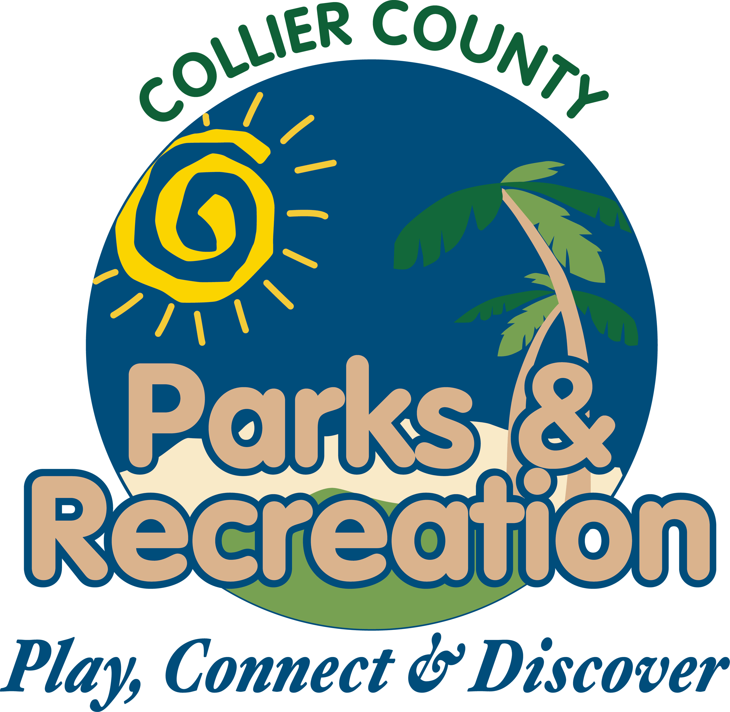 **Adjournment**