4th ANNUAL

GOODLAND

Goodland Civic Association and Collier County Parks and Recreation

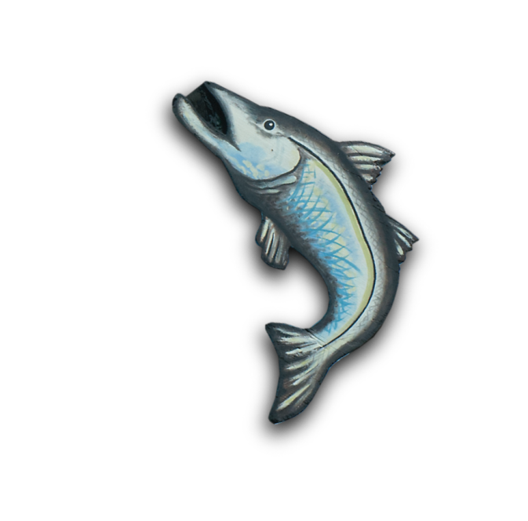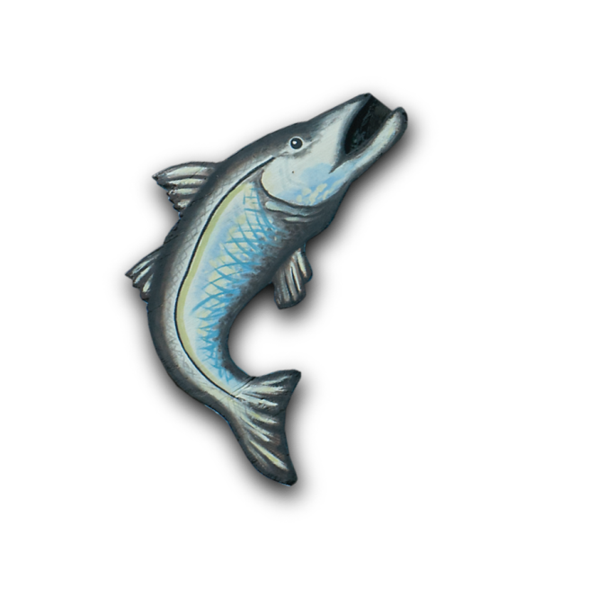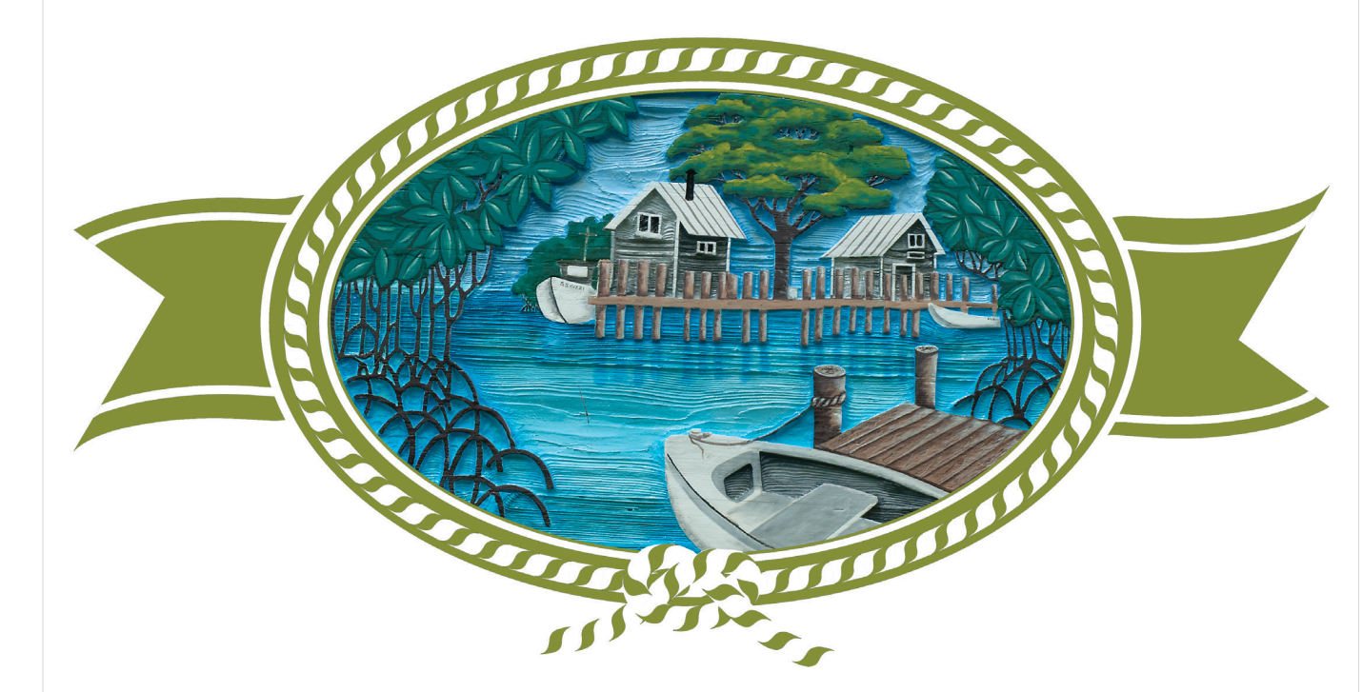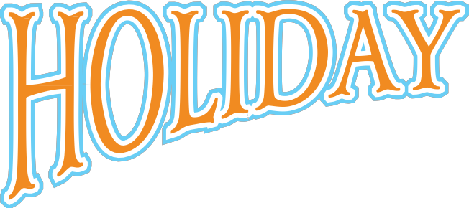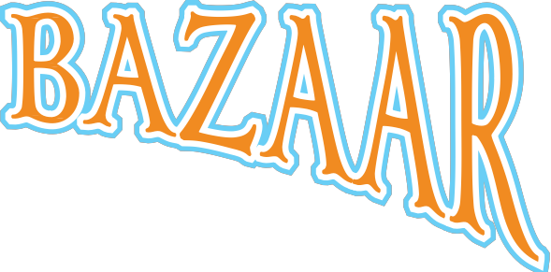

**Art, Crafts, Food & Music**

***November 16 – 17 / 10 am – 4 pm***

***Margood Harbor Park***

***321 Pear Tree Avenue***

***Goodland, Florida***