
Register for FREE at:
Immokalee Community Park
321 N. 1st Street
239-252-4449
Bring: Child’s Birth Certificate, Physical and Immunization records

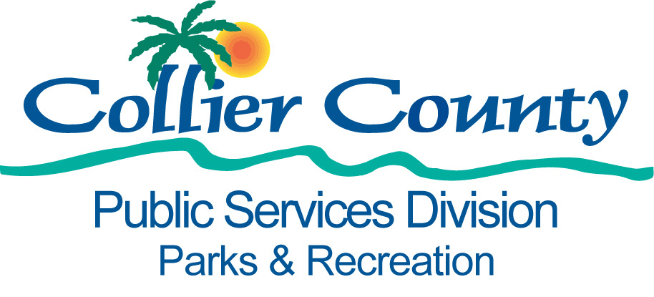
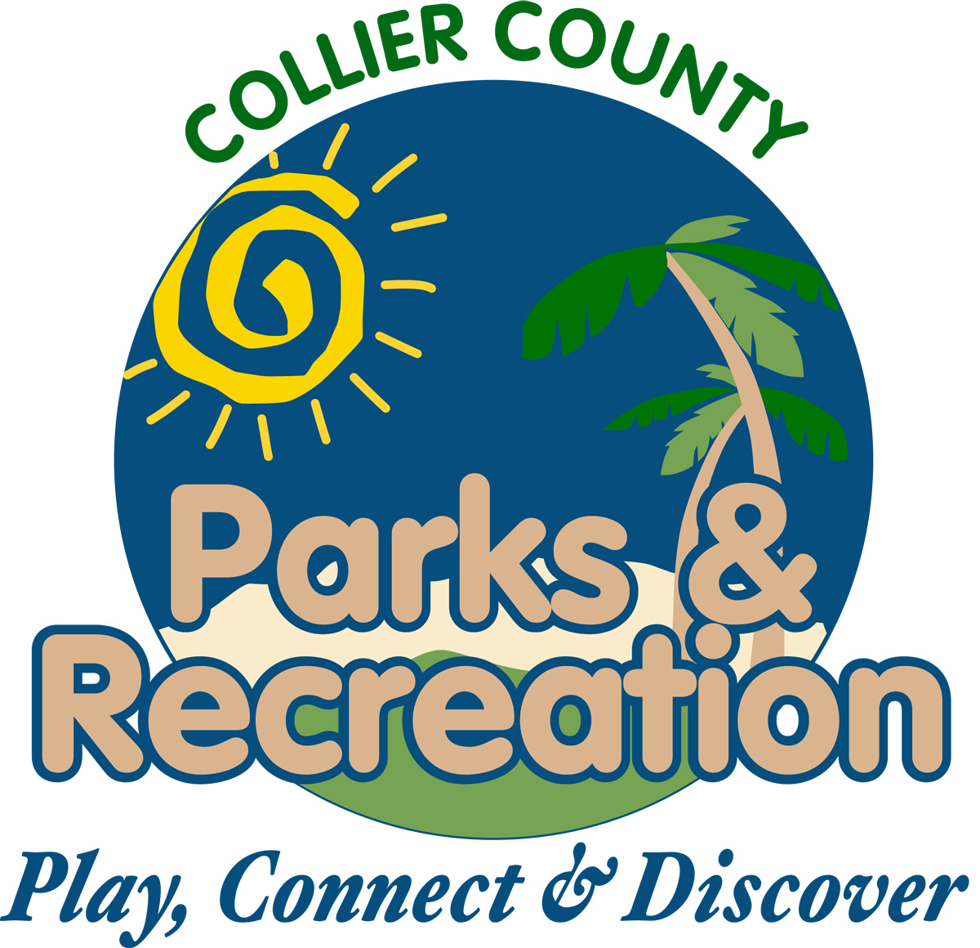
www.collierparks.com
239-252-4000
Registración GRATIS en:
Immokalee Community Park
321 N. 1st Street
239-252-4449
Traiga: Acta de nacimiento, examen físco y papel azul de sus vacunas.

Enregistreman GRATIS:
Immokalee Community Park
321 N. 1st Street
239-252-4449
Vini: Avèk bastistè, cat vacinatyon, et papié medical.

