Collier County Government 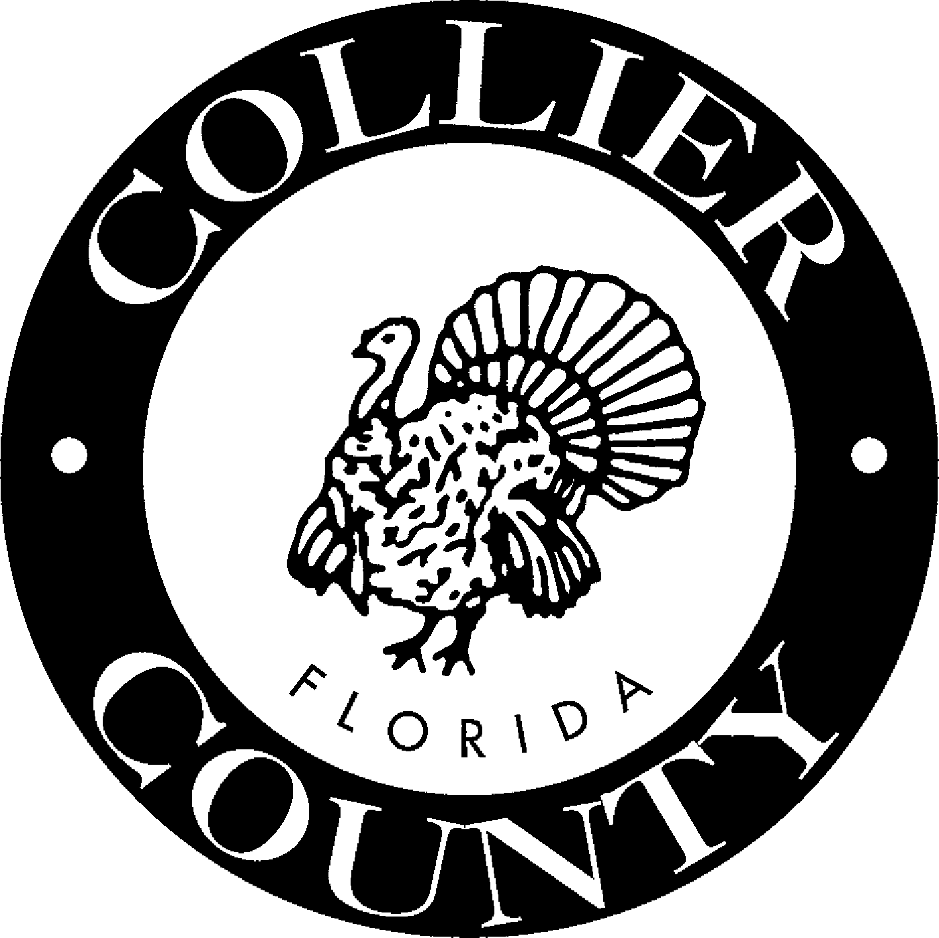

Communication & Contact: Sandra Arnold-Lawson

Customer Relations Department Public Information Coordinator
3301 East Tamiami Trail (239) 774-8308
Naples, FL 34112

June 15, 2005

FOR IMMEDIATE RELEASE

First WWII Veteran Interviewed For County’s Capture Living History Project

Naples resident William “Bill” Blaikie, a former Marine Corps Reserve Officer in both World War II and the Korean War, was the first participant to complete an interview for Collier County’s WWII Capture Living History project.

The 89-year-old former fighter pilot made the decision to join the military on Dec. 7, 1941 the day Pearl Harbor was attacked.

“I heard on my car radio that we had been attacked, while going to the airport from my TWA job,” said Blaikie. “I knew exactly what I was going to do then. I was going to get into one of the two services, I just didn’t know which one at the time.”

Not long after finishing his Civilian Pilot Training Program, a program established in 1938 under President Franklin D. Roosevelt’s administration, he selected the Marine Corps and became a flying instructor in Chicago teaching future pilots.

“The original field (landing strip) was too small for the new students, so the farmers went out and plowed their property flat, and that’s where we originally practiced take offs and landings,” Blaikie said. “It’s amazing to think that we started training on a dusty field.”

Once completed, Blaikie’s interview will be permanently archived for visitors to listen to at the Collier County Museum and the Headquarters Library.

For more information, call the Communication and Customer Relations Department at
774-8308.

-End-

