Conservation Collier Watkins-Jones Property Interim Management Plan

Prepared By:
Collier County Environmental Services Department
2800 North Horseshoe Drive
Naples, FL 34104

December 2005

Table of Contents

1.0 Purpose and Scope of the Interim Management Plan………………………… 3

- Management Authority and Responsibilities ……………………………….. 3

- Interim Site Plan ………………………………………………………….… 4
  - Location and Site Description ………………………………………. 4
  - Signage……………………………….………………..……………. 4
  - Easements, Concessions or Leases …………………………………… 4
  - Structures………………………………………………………..…… 4
  - Surrounding and Adjacent Land Uses…………………………………. 4

- Interim Management Objectives ………………………………………….… 4
  - Natural Resource Protection…………………………………….…… 5
  - Site Security……………………….………………………...………. 5
  - Exotic Vegetation Removal and Maintenance Plan……………….….. 5
  - Debris Removal………………………………………………………. 6
  - Cultural, Historical and Archaeological Resource Protection...……… 6
  - Public Access……………………………………….………….….... 6
  - Site Monitoring Plan………………………………………..…..…… 7

- Exhibits……………………………………………………………………..… 8
EXHIBIT 1: Location Map
EXHIBIT 2: Aerial Map
EXHIBIT 3: Estimated Cost Table
EXHIBIT 4: Implementation Timeline

Purpose and Scope of the Interim Management Plan

The Watkins-Jones property was purchased by Collier County in August 2005 with funds from the Conservation Collier program. The property will be managed only for conservation, protection and enhancement of natural resources and for public outdoor recreation that will be compatible with the conservation, protection and enhancement of the site and its surrounding lands.

This Interim Management Plan is intended to identify the key management priorities and issues within the site and give direction for management for the next two years. This document is meant to be the precursor to a Final Management Plan, which will outline more specific aspects of site management.

Key Interim Management Objectives
- Protect, manage and restore (as appropriate) the native habitat on site
- Determine what actions will be necessary to open the site for public access
- Explore opportunities for grant funding and partnerships
- Meet with community members who have an interest in this property and obtain feedback for Final Management Plan

Action Plan
1a. Remove and manage invasive exotic vegetation
1b. Plan for native vegetation restoration if necessary
2a. Install temporary Conservation Land signs along US 41 boundary
2b. After initial exotic vegetation removal is complete, determine and begin the appropriate actions necessary for developing public access.
2c. Obtain a survey of the north boundary line.
3a. Explore possible exotic vegetation removal grants from USFWS and FL DEP.
4a. Meet with members of the North Bay Civic Association and neighboring developed
property owners for management plan input
4b Develop a Memorandum of Understanding with Future Citizens, Inc. group for access to property by children’s groups.

- Management Authority and Responsibilities

The Collier County Environmental Services Department will be solely responsible for managing the Watkins/Jones property, but will seek to obtain grants, and utilize partnerships and volunteers for management activities.

Interim Site Plan

3.1 Location and Site Description
The Watkins/Jones property is within the urban boundary of Collier County located along US 41 just south of Wiggins Pass Road and south of the Germain Automobile dealership in Section 16 Township 48 Range 25, in the northwest corner of Collier County, Florida. The undeveloped 26.77 - acre site contains various native plant communities, including pine flatwoods, mangrove forest and both saltwater and freshwater marshes.

  - Signage
A temporary sign identifying the property as Collier County conservation land will be posted along US 41. A temporary no trespassing sign will be posted along the northern border.

3.3 Easements, Concessions or Leases
No easements, concessions or leases currently exist within the site, nor are any easements, concessions or leases proposed for the future, unless they further conservation objectives, such as a conservation easement.

3.4 Structures
There is an eagle observation platform constructed by Future Citizens, Inc. located on or near the north property boundary. This platform is currently being used by children staying at the camp to view the eagle nest. A survey of this boundary to determine the exact location of this structure is needed to be certain it does not encroach on the Watkins/Jones parcel.

3.5 Surrounding and Adjacent Land Uses
The Watkins/Jones parcel is adjacent to developed commercial property (Germain Automobile Dealership) and a children’s camp (Future Citizens, Inc.) on the north side, developed residential on the west side (Gulf Harbor Subdivision) Conservation land and Wiggins Bay Estuary on the south, and US 41 on the east.

4.0 Interim Management Objectives

4.1 Natural Resource Protection
Existing Vegetation:
Ground Cover:
Pine flatwoods – native grasses and herbaceous plants
Mangroves – Giant leather fern (Acrostichum danaeifolium), swamp fern (Blechnum serrulatum)
Saltwater marsh – marsh elder (Iva frutescens), sea oxy daisy (Borrichia frutescens), Christmas berry (Lycium carolinianum), black needle rush (Juncus roemerianus), cordgrass (Spartina spp.)
Freshwater marsh – sawgrass (Cladium jamaicense), swamp lily (Crinum americanum), Giant leather fern (Acrostichum danaeifolium), umbrella sedge (Fuirena), native wetland grasses (Distichlis spp. & Paspalum spp.)

Midstory:
Pine flatwoods – Saw palmetto (Serenoa repens), galberry (Ilex glabra), sumac (Rhus copallina), wax myrtle (Myrica cerifera), rusty lyonia (Lyonia sp.) with quite a bit of exotic downy rosemyrtle (Rhodomyrtus tomentosus)
Mangroves – saltbush (Baccharis halimifolia), Indigo berry (Randia aculeata)
Saltwater marsh – no midstory plants
Freshwater marsh – no midstory plants

Canopy:
Pine flatwoods – slash pine (Pinus elliotti), cabbage palm (Sabal palmetto) with some scattered melaleuca (Melaleuca quinquenervia)
Mangroves – red mangrove (Rhizophora mangle), black mangrove (Avicennia germinans) white mangrove (Laguncularia racemosa), buttonwood (Conocarpus erectus)
Saltwater marsh – scattered buttonwood (Conocarpus erectus)
Freshwater marsh – pond apple (Annona glabra)

Unique Natural Features:
The site contains saltwater and freshwater marshes, both considered unique and endangered by Ordinance 2002-63. These wetlands buffer and protect the Wiggins Pass Estuarine System, designated as an Outstanding Florida Water. An active bald eagle nest exists on the parcel.

Possible Listed Species:
The observed habitat and location would support presence of the following listed species: bald eagle (Haliaeetus leucocephalus), common snook (Centropomus undecimalis), American alligator (Alligator mississippiensis) and FFWCC SSC wading bird species: little blue heron (Egretta caerulea), reddish egret (Egretta rufescens), snowy egret (Egretta thula), tri-colored heron (Egretta tricolor), white ibis (Eudocimus albus), roseate spoonbill (Ajaia ajaja). Wood storks (Mycteria Americana) have been observed on the property.

Exotic Vegetation:
Invasive exotic plant species observed include: air potato (Dioscorea bulbifera), Australian pine (Casuarina spp.), Brazilian pepper (Schinus terebinthifolius), climbing fern (Lygodium spp.), downy rosemyrtle (Rhodomyrtus tomentosus), earleaf acacia (Acacia auriculiformis), java plum (Syzygium cumini), melaleuca (Melaleuca quinquenervia), shoebutton ardesia (Ardisia elliptica), banana (Musa sp.)

4.2 Site Security
There is currently no known site security issue associated with the Watkins/Jones property. Dense vegetation and/or wetlands at all property borders make access very difficult; however, as a precaution, a temporary no trespassing sign will be posted along the northern border. Once initial exotic vegetation removal has been completed, potential site security issues will be assessed.

4.3 Exotic Vegetation Removal and Maintenance Plan
The Collier County Environmental Services Department will hire contractors to treat the exotic vegetation on the site. Approximately 10 acres of uplands and non-mangrove wetlands are affected to a significant degree by exotic vegetation. If possible, the dense exotic vegetation along the north and east boundaries that is visible from US 41 will be cut and removed. Because it is difficult to access, the remaining exotic vegetation throughout the property will be treated in place and remain onsite.

4.4 Debris Removal
Currently, staff is not aware of any large trash items existing on the property.

  - Cultural, Historical and Archeological Resource Protection
The Watkins/Jones property is not within an area of historical and archaeological probability, and no historical or archaeological sites appear to be present on the property. The County will notify the Division of Historical Resources immediately if evidence is found to suggest any archaeological or historic resources are discovered. If such resources are identified on-site, staff shall cordon off the area, and a professional survey and assessment shall be instituted. The archaeologist shall prepare a report outlining results of the assessments and issue recommendations to County staff about management of any sites discovered, per provisions of the Land Development Code Section 2.2.25. This report shall be sent to the Division of Historical Resources. The County shall cooperate fully with direction from the Division of Historical Resources on the protection and management of archaeological and historical resources. The management of these resources will comply with the provisions of Chapter 267, Florida Statutes, specifically Sections 267.061 2 (a) and (b).

4.6 Listed Species Protection
Staff will evaluate needs for protection of existing eagle nest.

4.7 Public Access
Public access will be restricted until a path plan can be established; however, staff shall work with the owners of the Future Citizens, Inc. property to the north to develop an agreement for access by children’s groups using the Future Citizens’ site for educational and recreational activities.

4.8 Site Monitoring and Long Term Management Plan
Monitoring of the site shall consist of invasive exotic vegetation re-treatment and listed species population surveying. The Environmental Services Department shall be responsible for property maintenance with tasks contracted out as deemed necessary. The site will be monitored for exotic vegetation re-growth semi-annually for two years following initial treatment. After two years, exotic vegetation will be monitored on a yearly basis. Staff will work with the North Bay Civic Association to coordinate any volunteer efforts in this regard.

4.8 Partnerships
Staff will seek out and evaluate potential for other types of partnerships for conservation, protection, educational, and funding opportunities. Staff will explore possible grants for invasive exotic vegetation removal including: USFWS South Florida Coastal Ecosystems Program, USFWS Partners for Fish and Wildlife Program (Conservation Collier Cooperative Agreement Modification would be required) and FLDEP Bureau of Invasive Plant Management Working Group Program.
5.0 Exhibits

EXHIBIT 1: Location Map
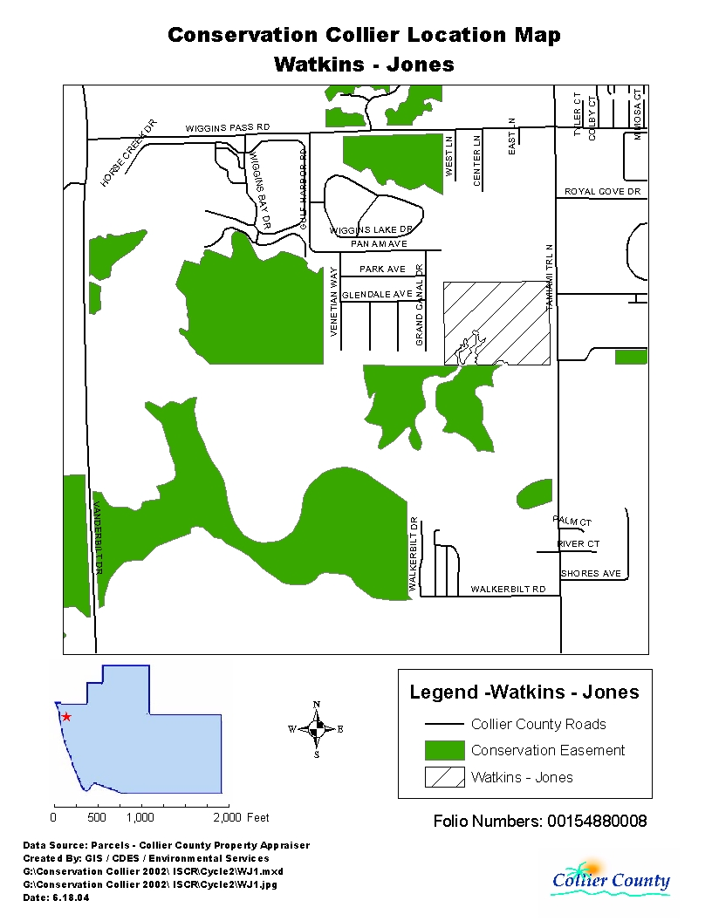

EXHIBIT 2: Aerial Map
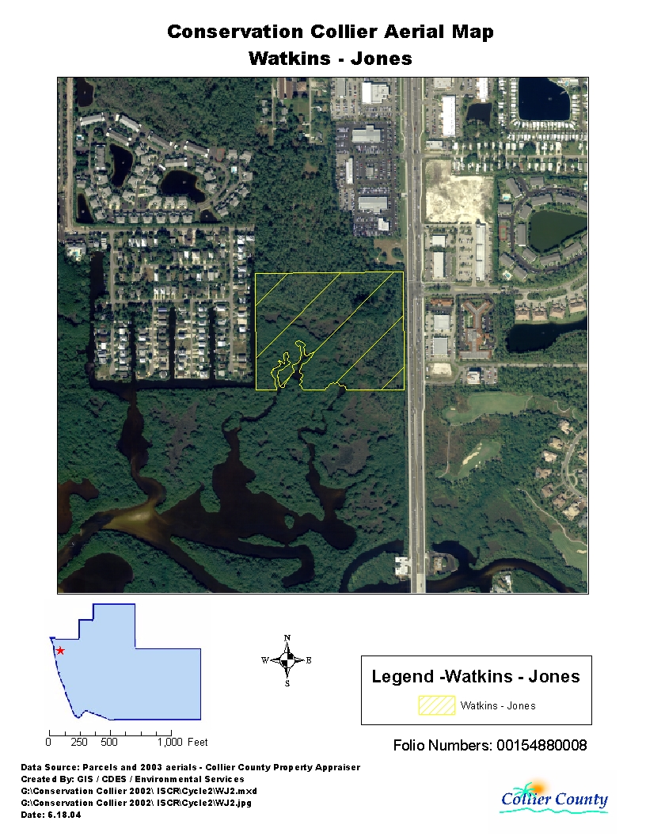

EXHIBIT 3: Estimated Cost Table

Management Element | Initial Cost | Annual Recurring Costs | Comments
Exotics Control | $37,500 | $4,500 | Initial cost depends on method of removal selected. Cost estimated on most expensive method.
Trash Removal | t.b.d. | t.b.d.
Temporary “No Trespassing” sign | $25 | n/a
Temporary Conservation Land sign | $100 | n/a
North Boundary Survey | t.b.d. | n/a | Needed to determine location of existing structure
Total | $37,625 | $4,500 +

EXHIBIT 4: Estimated Implementation Time Line

 | N  O  V  0  5 | D  E  C  0  5 | J  A  N  0  6 | F  E  B  0  6 | M  A  R  0  6 | A  P  R  0  6 | M  A  Y  0  6 | J  U  N  0  6 | J  U  L  0  6 | A  U  G  0  6 | S  E  P  0  6 | O  C  T  0  6 | N  O  V  0  6 | D  E  C  0  6 | J  A  N  0  7 | F  E  B  0  7 | M  A  R  0  7 | A  P  R  0  7 | M  A  Y  0  7 | J  U  N  0  7 | J  U  L  0  7 | A  U  G  0  7 | S  E  P  0  7 | O  C  T  0  7
Explore exotic vegetation grants (deadlines in April 2006) |  |  | X | X | X
Determine what actions necessary to open site for public use and develop timeline for opening
Install signs |  |  | X |  |  |  |  |  |  |  |  |  | X | X | X
Initial exotic vegetation removal (Sept 06 dates reflect grant timetable) |  |  |  |  |  |  |  |  |  |  | X | X
Work with North Naples Community Association for possible volunteer partnership |  |  |  |  | X | X | X |  |  |  |  |  |  |  |  |  |  |  |  |  |  |  |  | X
Develop an agreement for access with Future Citizens, Inc. |  |  | X | X | X
Completion of final management plan |  |  |  |  |  |  |  |  |  |  |  |  |  |  |  |  |  |  |  |  |  |  |  | X

