

Northeast Collier County Trail Feasibility Study:
Public Meeting Summary

Draft: July, 2008



PUBLIC MEETING SUMMARY

On Thursday June 5th, the Northeast Collier County Trail Feasibility Study team hosted a public meeting from 5:00 to 7:00 pm at the University of Florida Extension Service, 14700 Immokalee Road in Naples. The meeting was publicized through two advertisements in the printed media, a direct mailing and information posted on the variable message boards on local roads. The meeting was well attended with a consistent flow of traffic at the six stations throughout the room. A representative from the Naples Daily News was on hand to provide coverage of the meeting. The story is available at (http://www.naplesnews.com/news/2008/jun/05/workshop-greenway-trails-draws-small-crowd/).

The following comments were recorded from the team members stationed around the room:
- The County Commissioner, Jim Coletta, is very supportive of the trail system. He would like to see all or as many segments in place as possible.
- There are a lot of bikes in this part of the County
- A path 6 feet wide is better than no path at all (along Oil Well Road).
- FDOT should consider a trail located within the expanded SR 82 and include in PD&E study.
- Alignment 3A is tight (crowded).
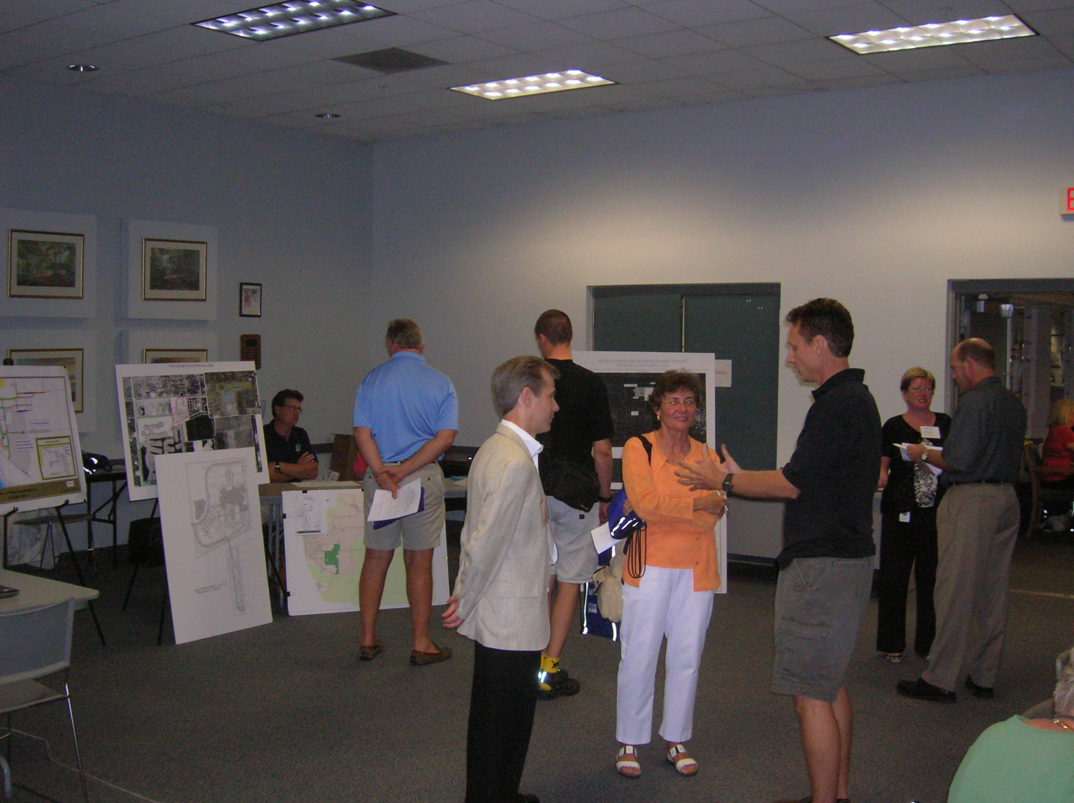
- Using power line easement for trail alignment would minimize vehicle conflicts/crossings.
- Trail through town of Immokalee should be a priority.
- If trail is located in SR 82 right of way, consider CR 850 for connection back to Segment 7 if needed.
- Want a safe and continuous route for trail.
- Use trail for commute to work and route to Ft. Myers; make it safe.
- Review Westclox vs. Lake Trafford alignment.
- A lot of people will want to use section 3D or 3C.
- Would love to see Immokalee have a trail.
- There are bike racks all over Immokalee.
- Mitch with the Orange Grove Company wanted to be kept in the loop and was concerned w/their operations of the orange grove as well as their concern with being made to pay for the improvements.
- “Have we conducted an environmental assessment” and “have we determined what environmental permits will be required (i.e. SFWMD, Fish and Wildlife, etc)?” This question came from an employee of Johnson Engineering and he was offering his services.
- Question from the Parks and Recreation Department representative and 1 other attendee about long-term management costs.
- Strong presence from the Naples Pathway Committee
- Request for good trail heads with a tie-in to local developments
- “Build all the alignments....”

PAC MEETING SUMMARY
The Pathways Advisory Committee (PAC) met on Friday morning, June 6th where the team presented the initial findings and trail alternatives. The following comments were received from the advisory committee:
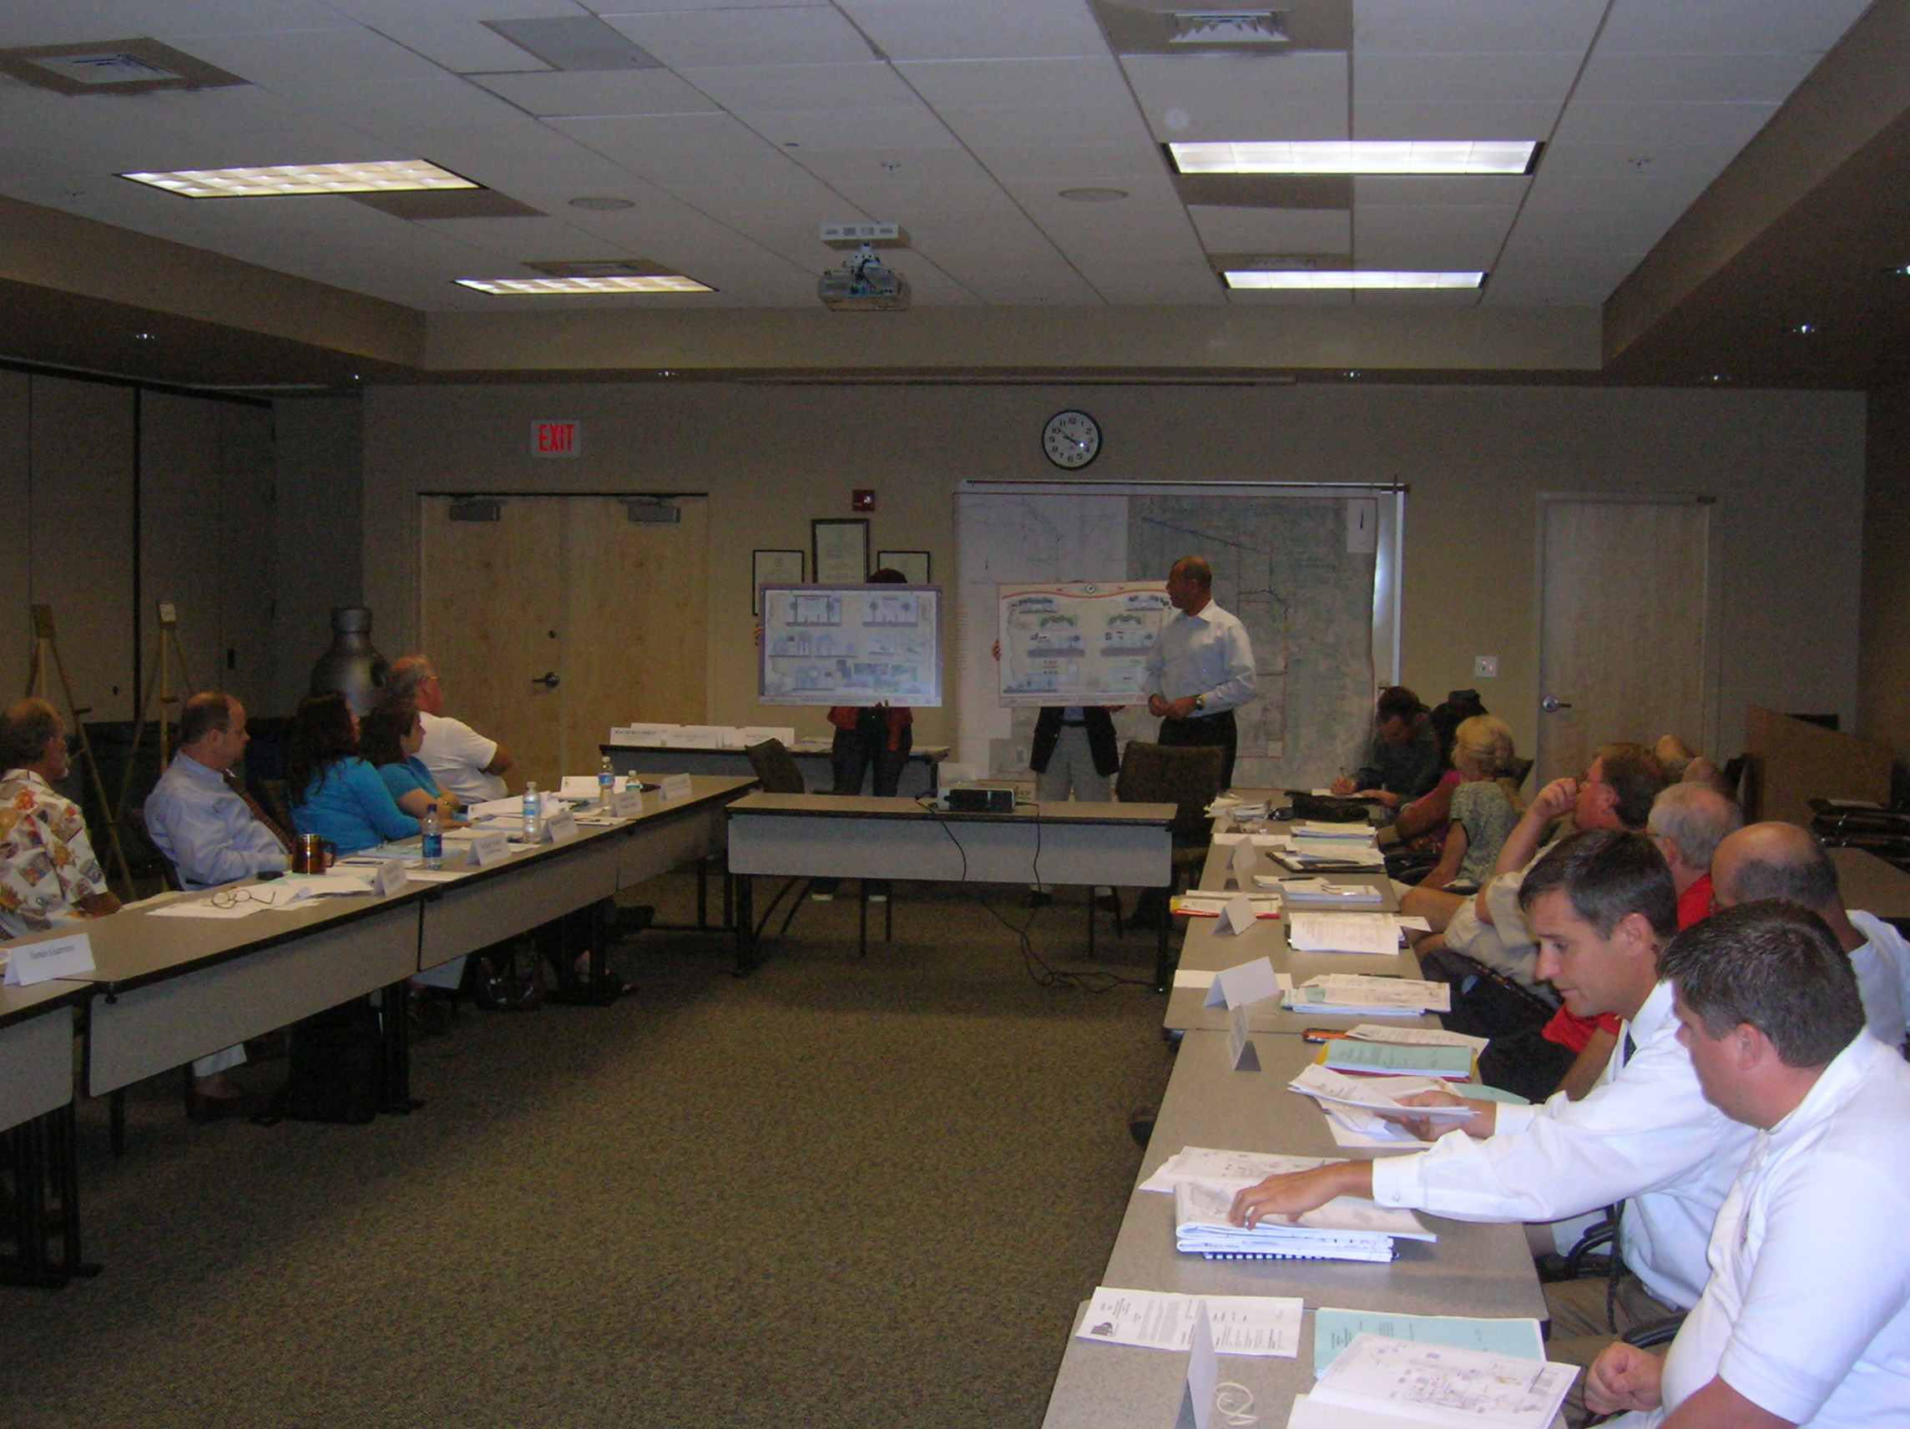
- Review study area for potential bridge connections and associated costs.
- Follow up with School Board and discuss “hazard sites” and possible link to trail funding
- Want to have trail access within a 2 mile radius
- Review potential connections to Hendry County trail system and to Lake Okeechobee.
- Lee County working on their trail planning program.
- Establishing safe routes to school should be a consideration by the County in its trail planning.
- Keep alternative corridors on map for future planning purposes

PUBLIC SURVEY RESULTS
As part of the public outreach process, a survey was developed to gather feedback from local residents and potential trail users. Attendants at the public meeting had the opportunity to complete the survey on-line and were also provided printed surveys to fill out after the meeting. The on-line survey was publicized on the Collier County website and was available for submission from the date of the meeting until June 30th, 2008. During that time, 190 responses were received and the data is summarized below.

1. | Yes
2. | Yes.
3. | Yes. I would really appreciate more bike friendly routes around the county and a trail would be a great contribution.
4. | Yes, but it should really connect all of Collier County, including downtown, the beaches, shopping at the mall.
5. | Yes, if it's actually for walking or biking. No, if it's for political convenience/p.r. of private developments like Ave Maria or the town of Big Cypress.
6. | Yes
7. | Absolutely.
8. | Yes
9. | absolutely
10. | Yes!!
11. | Definitely!
12. | 1000 percent, yes, one thousand
13. | Yes
14. | Yes
15. | Yes
16. | Yes
17. | Yes
18. | Yes
19. | Yes, especially close to our neighborhood, or in our neighborhood
20. | Yes
21. | Yes
22. | Yes
23. | Yes
24. | Yes
25. | Yes
26. | Yes
27. | Yes
28. | Yes
29. | Yes
30. | Yes, we have a great need of safe walk & bicycle paths along Immokalee Road, especially near the Corkcrew Sanctuary.
31. | Yes
32. | Yes
33. | Yes
34. | Yes
35. | Yes
36. | Yes
37. | Yes
38. | Yes
39. | Yes
40. | Yes
41. | Yes
42. | Yes
43. | Yes
44. | Yes
45. | yes
46. | Yes
47. | Yes
48. | Yes!
49. | yes
50. | Only if it is done sustainably.
51. | Yes. This is even more important now with the unrestrained surge in gas prices.
52. | Yes.
53. | yes
54. | YES
55. | Yes, definitely it is needed.
56. | Yes
57. | Fix this page, I can not exit.
58. | No, this is too much expense for Collier County to incur at this time.
59. | yes
60. | possibly
61. | Yes
62. | YES!
63. | Yes! Yes! Yes!....This sounds like North Naples! I agree with this, however what happened to the approved greenway trail between Rattlesnake & Radio in East Naples..It is hard to give support, then see the plan just fade away???? Please give me some feedback.
64. | Yes.
65. | YES!
66. | Absolutely!!!!!
67. | Yes. Emphatically.
68. | yes
69. | Yes
70. | Yes
71. | yes
72. | Yes!!
73. | yes
74. | Yes. My husband and I both would use the trail.
75. | yes
76. | YES.
77. | yes
78. | yes
79. | Yes
80. | Yes
81. | Yes.
82. | yes
83. | yes
84. | Yes, we need more safe greenways in Collier County for healthy recreation opportunities and alternative means of transportation.
85. | Yes
86. | yes
87. | Yes
88. | Most Definitely
89. | YES
90. | Yes - very much
91. | As an avid bike rider and some time commuter by bike, I fully support the greenways project. As a bike shop management, I see so many benefits to cycling safely. Please consider Everglades Boulevard as possible pathway all the way to the Picayune Strand Forest.
92. | yes
93. | Yes, for many reasons: environmental, health, eco-tourism, recreational
94. | ABSOLUTELY!
95. | Yes. I think there is a great need for these greenways and a great idea.
96. | Yes! Yes! Yes !!!
97. | Yes, passionately. The best sport in the world.
98. | Yes I do
99. | Yes. I ride my bike throughout the County but we have no safe pathways from Naples to Immokalee or Naples to Marco Island or Marco Island to Everglades City. We would love to ride to other cities in our county.
100. | Yes
101. | Yes
102. | Passionately
103. | Yes we need this network and east/west route tot he City of Naples corridor.
104. | Absolutely. Impressively important for safety reasons for workers and recreational riders who want to walk, ride + recreate with non-motorized venues. Families also looking for safe pathway to recreate. Rails-to-Trails options are well utilized.
105. | I would prefer a trail that is not paved for running and horseback riding. Is it possible to have both paved and unpaved?
106. | Yes. I believe it will greatly assist school district by providing students with a safe walk to school in some areas (they qualify for transportation over 2 miles) vs. riding a school bus depending on locations of future schools/communities.
107. | It depends. What are the costs first of all? How much interest exists for such? Are they justified at this time of low tax revenue and budget crunches? I would not personally use such.
108. | yes
109. | Yes
110. | yes
111. | as a property owner I do
112. | Yes
113. | Yes
114. | Yes, very much so. Southwest Florida is a beautiful place to live. Let’s try our best to keep it that way now and for future generations...
115. | YES
116. | yes
117. | yes
118. | Yes, this would be wonderful.
119. | Yes
120. | Yes!
121. | Most definitely
122. | yes
123. | Yes! We absolutely need greenways in our community!
124. | yes
125. | Yes!
126. | YES!
127. | Yes
128. | yes
129. | NO
130. | Yes
131. | yes
132. | Yes
133. | Yes
134. | Yes
135. | Yes.
136. | Yes, very strongly!
137. | YES
138. | yes
139. | It depends. I support them if it's not going to encroach on peoples land. I don't much care for the idea of people walking all hours of the night right up against our property, nor would most people.
140. | Yes
141. | Without a doubt!
142. | I do support greenways. I am a regular cyclist and runner.
143. | Yes
144. | Yes! Especially linked to Lee County
145. | YES
146. | Yes
147. | Yes
148. | Yes. I would like safe bicycle access to Naples and all of Collier County. Paths must be separate and secure from vehicle traffic.
149. | Most definitely
150. | yes
151. | Yes
152. | yes
153. | YES
154. | yes
155. | YES
156. | no
157. | Yes
158. | Yes!!! Very very much
159. | Yes
160. | Yes, absolutely. Our beautiful County suffers from lack of past planning in this regard and as a result has fallen far behind others in this important amenity.
161. | Yes, strongly
162. | Yes
163. | yes
164. | Yes the entire county should be accessible by trails
165. | yes
166. | I think this is a fabulous idea and fully support it.
167. | YES
168. | Yes
169. | Yes
170. | No. We need roads to provide safe end efficient transportation for vehicular traffic. There are sufficient county parks with paved areas for the activities proposed for the greenways. Likewise, sidewalks and bike lanes on new roads would provide the same benefit as the greenways without requiring the purchase of additional land.
171. | NO
172. | Yes
173. | NO! Not if the funds come from Transportation Dollars. This should be funded with tourism dollars or funding should come from parks and rec.
174. | Yes
175. | Yes
176. | Absolutely!
177. | only w/ a surplus in the budget to pay for "non-essential" amenities.... which generate NO revenue
178. | yes
179. | I fully support the creation of greenways in Collier. As an avid walker, hiker and cyclist I am very enthusiastic regarding the possibility of a trail in Immokalee to Ft. Myers.
180. | Yes. Last year we lived in Loveland, CO which has a 22 mile trail through the city. It was great for walking, riding, and socializing.
181. | NO
182. | Yes, This would be a great thing for the citizens to be able to get out exercise without have to deal with heavy auto traffic.
183. | Yes
184. | Yes
185. | Yes, by all means!
186. | yes - particularly if it is done as a partnership with land owners.
187. | Yes

1. | Yes - walked
2. | I liked riding the trail but there are three problems with it currently. 1. The end of the trail near I-75 is hard to get to from the west, since Immokalee road lacks bicycle lanes, the sidewalks are not well suited for bicycles, and there is not crosswalk at Tarpon Bay Blvd, 2. At the east end of the trail at Rose blvd. there is no convenient way to cross Immokalee road to continue going east. 3. No part of the trail is shaded.
3. | Bicycling this path is not the most 'fun' I've had. The pavement/concrete is separated in several spots, and it's quite bumpy. But it's better than nothing!
4. | I didn't know it was there
5. | I did not enjoy the experience in Immokalee. I prefer the dedicated bike lane on Immokalee from 951 east.
6. | I have biked that trail many times, but since it does not connect with a biking friendly access, it is not very useful.
7. | Immokalee Road Trail: No shade trees, only 4 uninterrupted miles of asphalt trails. Concrete sidewalks not traversable for running, biking, rollerblading as they are just that, Concrete. Cracks, bumps, traffic interruptions are horrible. Asphalt trails on Vanderbuilt Beach Road and 951 have been destroyed due to road expansion; concrete sidewalks are not acceptable replacements for activities other than walking. Collier Co is looking more and more like Dade Co with the lack of previous amenities.
8. | Didn't know about it.
9. | I have seen this trail but did not know it was all clear and open. I look forward to giving it a ride. I wish it were much longer.
10. | Yes. Enjoyed the feeling of safety from traffic. Love the outdoors.
11. | Yes
12. | The biggest problem w/trails in Collier County is they don't connect which limits their use.
13. | Bicycle use of sidewalks is dangerous and their abuse is so completely ignored by authorities.
14. | I live close to Collier and Vanderbilt Beach Rd. Wish it were a bit easier to get to that path. The Collier & VB intersection is currently SO dangerous - even for cars.
15. | No, most of the time trees and grass are over powering.
16. | Have not tried it because it is too far from my home.
17. | Yes.
18. | N/A
19. | didn’t know it existed
20. | Trails are not as long as we enjoyed in our home state of Iowa.
21. | No....I haven't seen it....
22. | no
23. | I have not used the trail. I am more likely to use a trail in the Corkscrew Island neighborhood where I work.
24. | Yes. It would be nice if there could be more separation from the roads but I understand this is often very difficult to achieve.
25. | Yes because of personal safety(not having to worry about motor vehicles)
26. | It is a pleasant walk, far enough from the road (I-75).
27. | yes, easy access for me
28. | Yes, ones separated from the road are most pleasant to use.
29. | It has been a good experience though somewhat diminished by the amount of traffic on Immokalee Rd.
30. | Yes, it was very pleasant.
31. | NA
32. | Yes
33. | I was almost killed this spring on Everglades Boulevard. Will not ride it again until road is bike friendly.
34. | Much more pleasant if part or all of the trail can go through natural sites rather than next to busy road
35. | I very much have enjoyed being off the road on a dedicated pathway like that on Immokalee Road from I-75 to Collier Boulevard.
36. | Too far away
37. | Yes because it was safe and smooth and connects developments with schools. Please make this trail happen.
38. | Not yet.
39. | Have not biked it yet
40. | I bicycled along the Immokalee Road greenway and Logan Boulevard and Oakes Boulevard when I commuted to work last week. Great to be safe, even at night.
41. | Somewhat enjoyable with too many crossings.
42. | Safe, smooth and connecting schools & residential developments. Also safe area for families with children to recreate safely.
43. | N/A
44. | no I have not yet
45. | N/A
46. | yes. any time I can bike somewhere safely, it's a pleasure
47. | Yes, it was a safe way to walk/jog/cycle along a busy roadway.
48. | The experience would be fine if they were safely connected. Some trails require the bicyclist to ride alongside traffic which is extremely dangerous.
49. | Yes, when the space is maintained attractively and safe from car traffic.
50. | yes - it put me out in nature, and kept clean.
51. | Where is this trail?!! Something similar I've done is biked Shark Valley. It's nice to have an area to bike/walk, etc. where you can enjoy the outdoors/scenery, and feel safe while doing it, not having to worry about being hit/killed by a vehicle.
52. | yes we need more alternatives to enjoy our area safely and get some exercise at the same time.
53. | Bicycles cause huge amount of damage to the land. Every state I have visited reports problems with recreational cyclists.
54. | Yes, it is wonderful!
55. | I have biked this trail, and it is too short for any enjoyment, as well as dead end on both ends at a non-destination venue. Not much to look at except Immokalee Road, so the scenery is absent.
56. | have not
57. | You get very dirty from the road pollution - and it triggers my asthma attacks (set back from the road more would be better)
58. | Yes. This trail could be improved significantly by connecting to the intersection of Immokalee Road & CR 951. Also a connection to the CR 951 trail would be a great improvement. It is a much more enjoyable experience to walk or ride with a nice separation from vehicles.
59. | Yes, my wife and I have bicycled the new trail (and side walk) between I-75 and Rock Road several times. We like it because it connects us with so many locations via bikes.
60. | YES, ENJOYED
61. | No. There was no place to park and I wasn't confident that my car was safe. Still had to encounter traffic at road intersections. Trail needs to get away from roads. That is basically a really nice sidewalk.
62. | I have not walked it
63. | Too hard to safely get to the few trails that we have in Collier county. We need many more!
64. | I have not used this trail because I do not live close to it and I would like a more extensive trail system to make it worth my trip.
65. | did not know about it...would love to try it
66. | Never been on this trail.
67. | Yes, It is great. Nice to be away from the traffic so you don’t have to worry about being run over.
68. | yes, because we feel safe.
69. | very much
70. | YES . EASY TO USE , AWAY FROM THE ROAD( THE FURTHER AWAY THE BETTER), WELL MAINTAINED
71. | I have used this pathway and found it an amazing change from the pathways that are nothing more then extended parts of the street. The shelter offered by a pathway of this nature allows you to truly enjoy the beauty of the ride… to get lost.. like a kid again
72. | n/a
73. | I use bike lanes (Vanderbilt Rd, Livingston, US41 occasionally) and have lots of biking experience so I am comfortable doing so, but I live part time in Colorado where separate bike paths are the norm. They are much more comfortable for the rider and don't invite auto/bike encounters.
74. | I have used the Immokalee rd and Logan trails and enjoy using both of them it is great to be away from traffic
75. | yes
76. | Was not aware of the above mentioned trail. I have walked in Corkscrew Sanctuary and Seminole State Park.
77. | IT'S FAR AWAY FROM ME. IT REQUIRES NO SPECIAL ATHLETIC GEAR TO WALK AROUND THE BLOCK.
78. | I did not know there was such a trail
79. | No Cannot safely access it from Star Grass Lane
80. | I was unaware of its existence. Because I would need to drive to a "trail head" in order to use it, I wonder if you have any parking adjacent to it.
81. | have not
82. | No I have not tried these trails, but I plan to. I have only been living in Naples for 2.5 years and have much to see and do.
83. | If this is the trail at Veterans I have not yet used. Otherwise I am unaware of this trail.
84. | This would be a waste of my tax dollars
85. | Did not know it was there.
86. | Yes
87. | Not yet....I did not know it existed!
88. | In order for regular users (as opposed to long distance trail riders) the trail needs to have destinations at regular intervals. Additionally, there need to be multiple access points for residential users, or to access retail establishments. The current trail (mentioned above) has limited destinations, and is not integrated into the developments. Again, coordination/partnering with land owners and developers may result in a more meaningful experience.
89. | Yes

1. | I really support the expansion of the trail. That said, having a trail is most useful when it runs along road or routes where there is no bike lane, and when access to the trail is relatively easy. For example, I don't use the current trail along Immokalee as much as I might because it is hard to get to the trail from west of I-75 due to construction and lack of bike lanes on Immokalee road west of I-75.
2. | Please replace asphalt trails destroyed by road expansion in N. Naples; Concrete sidewalks are not acceptable substitutes for biking, blading, wheelchair access etc.
3. | I can't wait to try this out! When will it be ready? We have needed something like this for a very long time. I have been an avid cyclist here for many years.
4. | Should come here first before Ave Maria
5. | Collier County needs more projects like this and a master plan tying them together. Please don't "paint in" any more dangerous bike paths next to roads like US41.
6. | Why not a trail that follows the Golden Gate canal? There is no where to bike/walk in the estates.
7. | Whatever we can do in this type of recreation/transportation is just great! Supporting kayak routes is also a priority for me.
8. | Do contact me, but I will leave my name. The county needs to maintain the outlying areas as much as they do around Naples and Marco.
9. | Please give feedback on the greenway approved at least 2 years ago. ( Rattlesnake to Radio in the FPL easement) Why no action? Why not get it started as all the residents in the area were looking forward to? Thank You in advance for your response.
10. | I'd prefer to ride along the easements than on Oil Well Rd.. I believe that the Alt. 1 route has more to offer (including route to Corkscrew Swamp) than the segment which places the bike route to Big Cypress and Ave Maria.
11. | I'm just concerned about the wildlife and the amount of trees to be cut down for this project.
12. | Keep it in natural areas as much as possible and away from roads and development.
13. | We oppose putting the trail for public use through a religious community.
14. | The Corkscrew Island neighborhood endures many impacts for the "greater good of Naples", including the ugly powerlines for FPL, the blasting from Jones Mining, many dump trucks hauling fill to Naples. Finally, there is a proposal for something good for the neighborhood. The neighborhood got the power lines, now give us the trail!
15. | It seems important to provide a bike link between Immokalee Road and the Town of Big Cypress, Ave Maria and Immokalee. Also, it would be great to have the trail past the high school on Oil Well Road. Great Job !!!
16. | This is Florida all of these a great start. Add Everglades all the way to the Picayune Strand to Immokalee Road.
17. | Greenways are the obvious component of eco-tourism that we are missing. They also promote healthy activities for our youth as well as the rest of us. Many of our workers cannot afford cars let alone gas and they need a safe pathway to get to and from work. This sis a forward looking solution.
18. | I think these particular segments would afford a great and pleasurable experience for those people who use these trails. I think it would be very popular. With the addition of 3C it would give the City of Immokalee good access to its use. A good investment for the health and well being of our citizens!!
19. | Follow the FPL power line if possible!
20. | Need more funding for bike paths and multi-use pathways. Need a traffic light that bicyclists could use. Riding a bicycle keeps one healthway.
21. | Please follow the existing FPL powerline
22. | Although I personally prefer to cycle/run away from roads (e.g. Alt 3) Immokalee deserves to have a multi-use trail. Corkscrew Island Neighborhood suffers impacts (from many mines (dump trucks) and the visual ugliness of FPL transmission lines. They deserve to finally get an amenity.
23. | Improvements in east-west trail & corridor need to be provided.
24. | Do not like Oil Well Road due to the fact entire road does not have continuous pathway. Offers confusion to recreationalists.
25. | Suggest meeting with school board transportation and facilities department to come up with a list of priorities in terms of walk zones or potential walk zones for students.
26. | Are you really sure this is more important than enhanced sidewalks in the Town of Immokalee? There are no sidewalks to the clinic yet many people travel on foot pushing and carrying infants!
27. | If trail goes beneath powerlines then use Alt 5 & Alt 6 if trail is NOT beneath powerlines, then use Segment 6 & Segment 7; Also a loop consisting of Alt. Seg 3d / Alt. Seg. 4/ Alt. Seg 5A/ Alt 5 / Seg 5; for Immokalee residents, this would be great
28. | If Collier county is going to spend money on a project like this, they should ensure that it will serve the numerous bike riders that inhabit Immokalee and need safe access to paths.
29. | I believe this trail should follow the FPL powerlines. ALT 1 travels near the Corkscrew Swamp Sanctuary and this is an excellent route to link-up with this environmental gem in our County.
30. | Whatever Collier County can do to make bicycling safe (that is not running on the street in the path of vehicular traffic) would be appreciated in this time of increasing gasoline costs.
31. | I would MUCH rather see money spent on greenways than on median landscaping!!!!
32. | I would loooooooooovvvve to see this trail built!!!! Outdoor activities such as biking, etc. are good exercise, and can save me money by allowing me to ride my bike to the library, CSS, etc. instead of driving. The trail would also provide access for bird watching.
33. | we need to make sure this benefits areas that show off our unique natural environments and not out of the way developments that are self motivated with their own agendas.
34. | We have been paying our taxes for years, and years to the county. This is a fantastic opportunity for that tax money to benefit our immediate neighborhood. Please don't give the project away to Ave Maria.
35. | Build less roads and build more pathways and sidewalks.
36. | I like all the proposed routes, the more bike trails the better (and safer).
37. | I'd honestly rather see my tax dollars go to use finding someplace for people with ATV's to ride safely (and, no, I do not ride one myself) as opposed to through my back yard.
38. | A future of high gas prices and health issues means we needed to develop recreational trails. Some trails may serve as transportation, but most will afford a low cost recreational experience that also improves personal health.
39. | In the future, I would ultimately like to see all segments, lines on the map, for future preservation.
40. | I would like to see a trail in the western part of Collier County.
41. | All segments should be preserved eventually.
42. | would LOVE TO SEE ALL SEGMENTS AND ALTERNATIVES BUILT THE MORE TRAILS THE BETTER FOR EVERYONE
43. | Naples Pathways Coalition would ultimately like to see all segments, lines on the map, for future preservation.
44. | The above are my minimum desires. More is better. Thanks for what you are doing!
45. | It is important to me to have a connection from Bonita Springs Imperial River Trail to the SFWMD Corkscrew trails Other connections: Falka Union canal GG blvd to Immokalee rd with an underpass at 858 this would connect to Sabal Palm school Hogan Island road north into Peppers Ranch connecting to Lake Trafford rd
46. | IN THIS ECONOMIC CLIMATE, THIS OR THESE PROPOSALS ARE FAR AFIELD OF THE NEEDS OF YOUR CONSTITUENTS, COMMISSIONER.
47. | Why can't the county finish one project before moving on to another?
48. | Good survey, but embedding the website link versus just the type would have been helpful. You could have had it open in a new window and warned people they would need Adobe Acrobat Reader to access it. I no longer walk or bike like I used to because there are few areas which are user friendly to get a safe work out. I am NOT a beach person. Too much traffic makes bicycling on any roadway dangerous even for an experienced rider. The side walks along the roadways are so close to the roadways with speeds of 45 MPH or more as to make a jog or powerwalk equally dangerous. My family does not live in a gated community. We don't want to live in a gated community, however, save for the suburbs of Tampa, everywhere else in Florida where I have lived have had some access for residents to more safely engage in bicycling, walking, running, etc. Glad you are looking into making this kind of activity available here. We don't need commercial/retail development in the Estates, we need some form of recreational access such as this trail!
49. | Thank you for all your hard work and dedication to see such an exciting project completed. I applaud your efforts.
50. | This needs to be stopped. There is no need to add trails that will need ongoing maintenance.
51. | I did not give an opinion on the preferred route as I could see clearly on computer the options
52. | Currently, the alt 3D is very dangerous. Going from New Market and crossing over Main to Westclox in a car is even dangerous sometimes.
53. | This is a great step in the right direction! Keep up the good work!
54. | Please do a more effective job of reaching out to major private land owners prior to solidifying any of your plans. Private land owners will most likely be willing to cooperate, if the County demonstrates they value the private land owner's input and opinions, and that the County will not turn this into another County mandate for land owners to pay for

