Figure 1
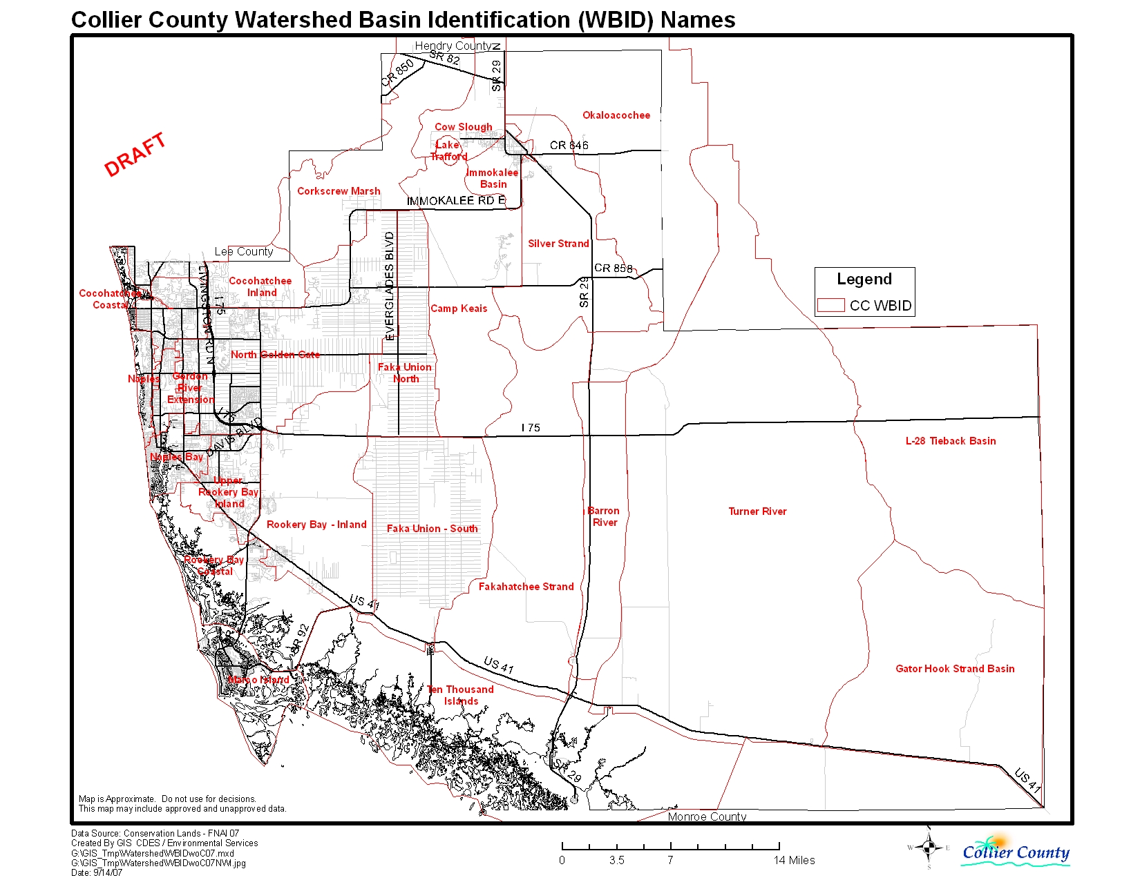

Figure 2
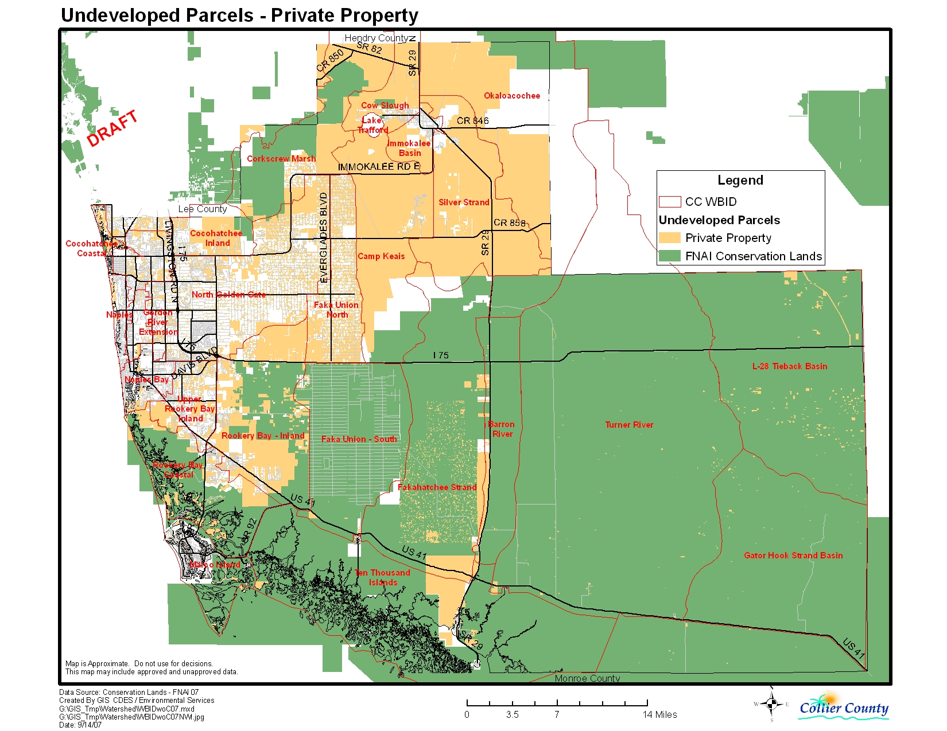

Figure 3
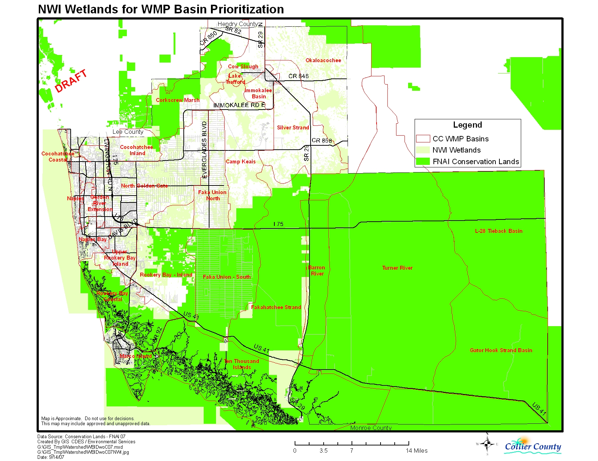

Figure 4
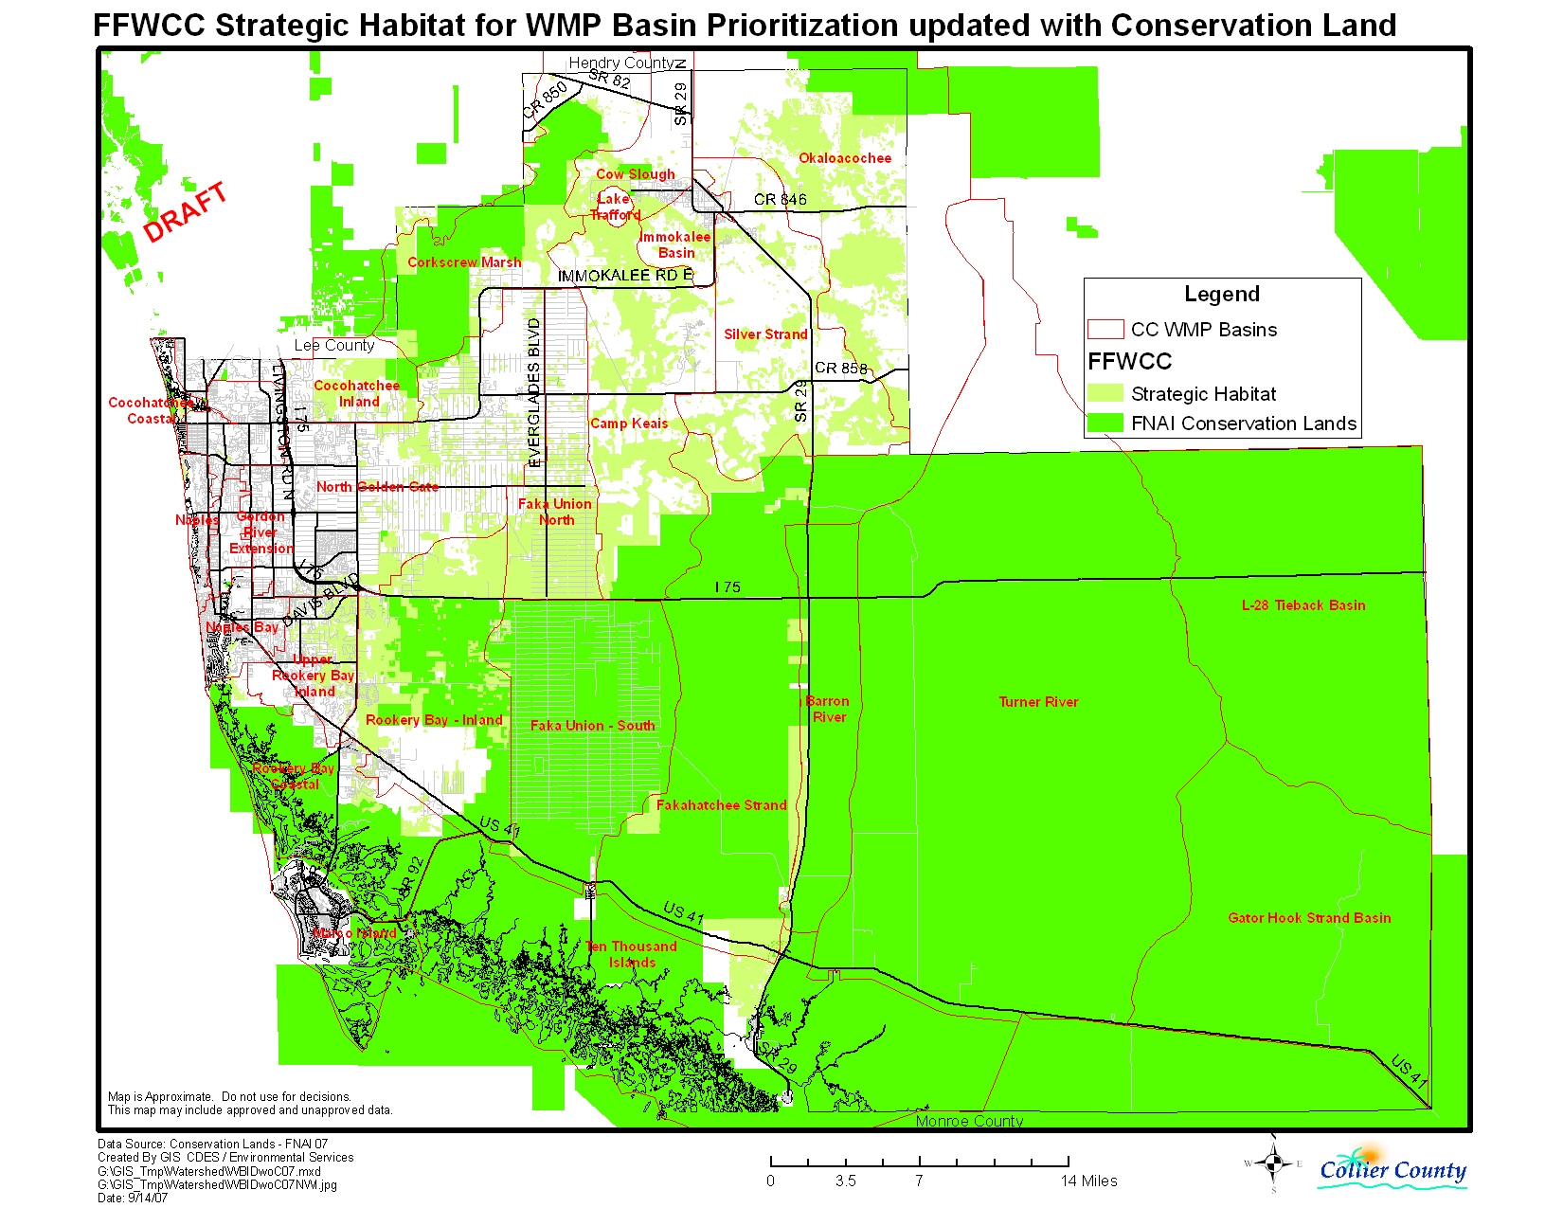

Table 1 Basin Summary and Rankings
 | Basin | Undevl | Undevl | Undevl | NWI Wet | NWI Wet | NWI Wet | St Hab | St Hab | St Hab | Average
Basin Name | acres | acres | Percent | Rank | acres | Percent | Rank | acres | Percent | Rank | Rank
Faka Union - North | 27449 | 18045 | 66% | 3 | 12301 | 45% | 3 | 15572 | 57% | 1 | 2.3
Camp Keais | 55718 | 41558 | 75% | 2 | 18659 | 33% | 7 | 25438 | 46% | 2 | 3.7
Rookery Bay - Inland | 53966 | 25819 | 48% | 7 | 19086 | 35% | 6 | 19538 | 36% | 3 | 5.3
Silver Strand | 53877 | 48997 | 91% | 1 | 11668 | 22% | 10 | 16943 | 31% | 5 | 5.3
Upper Rookery Bay - Inland | 15039 | 6478 | 43% | 8 | 6453 | 43% | 4 | 4790 | 32% | 4 | 5.3
North Golden Gate | 72793 | 28469 | 39% | 10 | 27319 | 38% | 5 | 12334 | 17% | 8 | 7.7
Cocohatchee - Inland | 25826 | 10317 | 40% | 9 | 6972 | 27% | 8 | 4885 | 19% | 7 | 8.0
Immokalee Basin | 8731 | 5639 | 65% | 4 | 1171 | 13% | 15 | 2111 | 24% | 6 | 8.3
Cocohatchee - Coastal | 3017 | 1118 | 37% | 11 | 1850 | 61% | 2 | 202 | 7% | 15 | 9.3
Cow Slough | 20903 | 12056 | 58% | 6 | 2705 | 13% | 16 | 3498 | 17% | 9 | 10.3
Corkscrew Marsh | 53323 | 17398 | 33% | 12 | 7445 | 14% | 13 | 7720 | 14% | 11 | 12.0
Okaloacochee | 145049 | 39918 | 28% | 13 | 19849 | 14% | 14 | 23431 | 16% | 10 | 12.3
Lake Trafford | 1489 | 6 | 0% | 23 | 1488 | 100% | 1 | 129 | 9% | 13 | 12.3
Naples | 4774 | 549 | 11% | 17 | 1106 | 23% | 9 | 104 | 2% | 18 | 14.7
Fakahatchee Strand | 94477 | 12753 | 13% | 15 | 11064 | 12% | 18 | 11287 | 12% | 12 | 15.0
Rookery Bay - Coastal | 38654 | 7415 | 19% | 14 | 4797 | 12% | 17 | 2143 | 6% | 16 | 15.7
Naples Bay | 9557 | 1276 | 13% | 16 | 1635 | 17% | 12 | 137 | 1% | 20 | 16.0
Gordon River Extension | 5168 | 3042 | 59% | 5 | 472 | 9% | 19 | 0 | 0% | 25 | 16.3
Marco Island | 20043 | 1086 | 5% | 19 | 3702 | 18% | 11 | 16 | 0% | 21 | 17.0
Barron River | 33367 | 2347 | 7% | 18 | 2210 | 7% | 20 | 2498 | 7% | 14 | 17.3
Ten Thousand Islands | 134270 | 6867 | 5% | 20 | 8296 | 6% | 21 | 3061 | 2% | 17 | 19.3
Faka Union - South | 59430 | 1019 | 2% | 22 | 818 | 1% | 22 | 1037 | 2% | 19 | 21.0
L-28 Tieback Basin | 117382 | 2455 | 2% | 21 | 397 | 0% | 23 | 86 | 0% | 22 | 22.0
Turner River | 283725 | 631 | 0% | 24 | 108 | 0% | 24 | 44 | 0% | 23 | 23.7
Gator Hook Strand Basin | 97737 | 191 | 0% | 25 | 0 | 0% | 25 | 0 | 0% | 24 | 24.7

