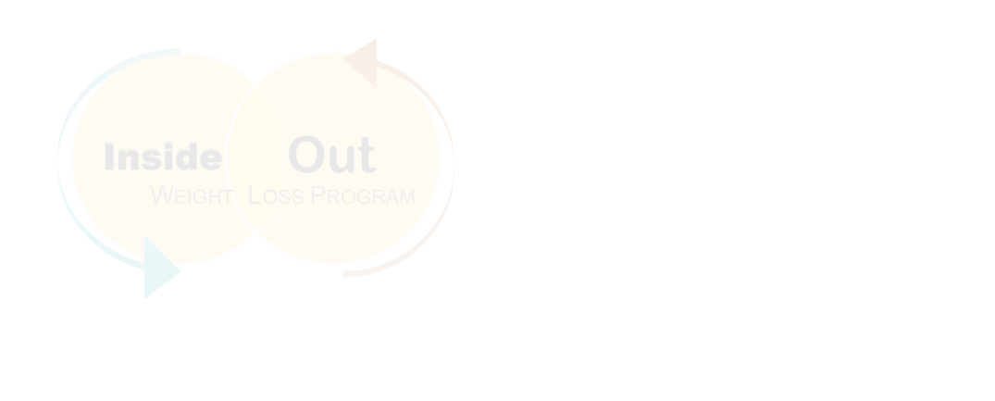Inside Out Weight Loss Program

Initial Evaluation Form—Physical Wellness

 **Fill out & Bring to Physical Wellness Visit**

